DBMS

Open these pages

<https://www.sanfoundry.com/database-mcqs-sql-basics-definitions/>

<https://www.sanfoundry.com/mysql-questions-answers-performing-multiple-table-retrievals-joins/#google_vignette>

<https://www.sanfoundry.com/rdbms-questions-answers-basic-operations/>

Which of the following is popular for applications such as storage of log files in a database management system since it offers the best write performance?

* RAID level 0 refers to data stripping. RAID level 1 refers to disk mirroring with block striping. RAID level 2 refers to bit-level stripping and RAID level 3 refers to byte-level striping with dedicated parity

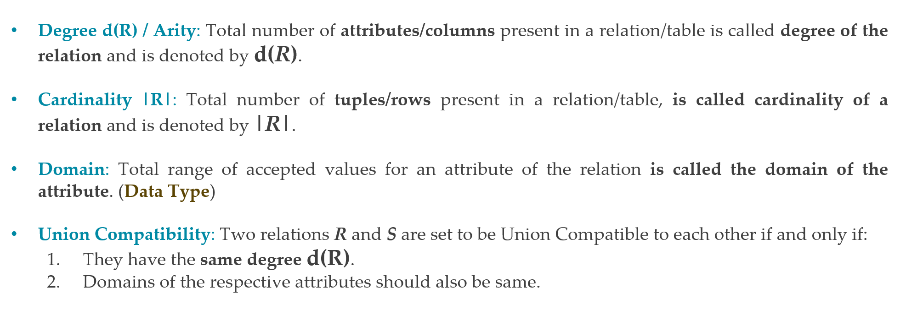

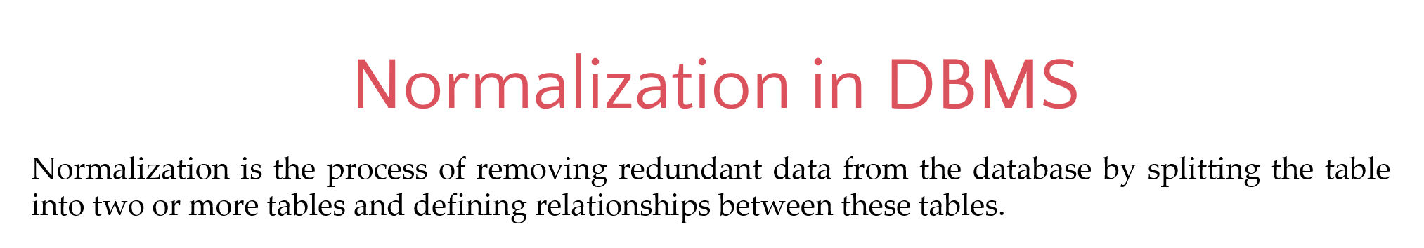

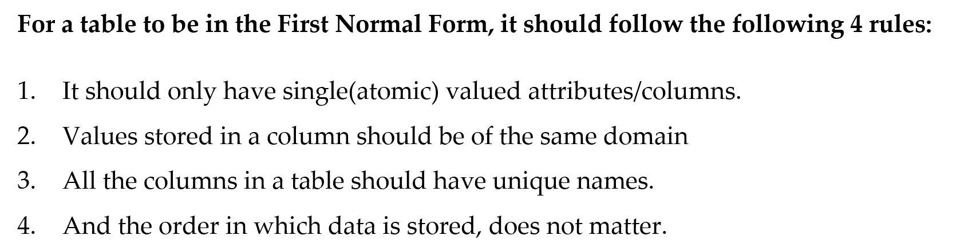

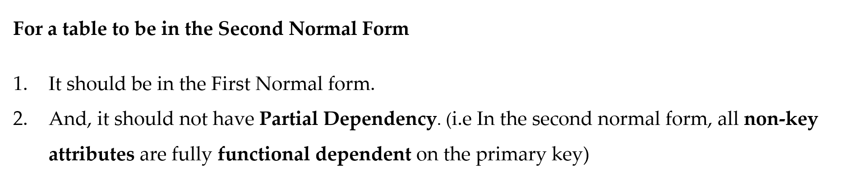

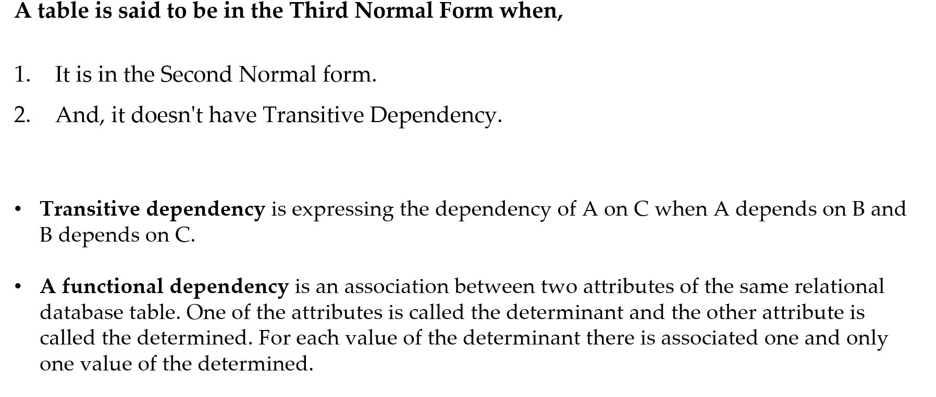

Example: ALTER TABLE orders ADD CONSTRAINT fk_customer FOREIGN KEY (customer_id) REFERENCES customers(id);



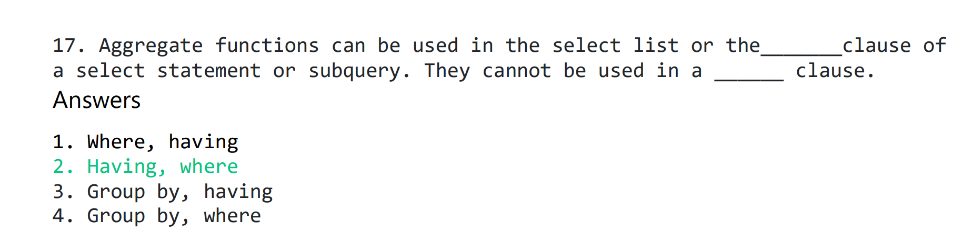

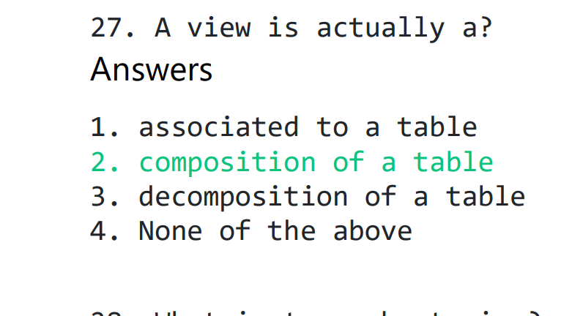

1. <https://www.sanfoundry.com/1000-database-management-system-questions-answers/#dbms-chapters>

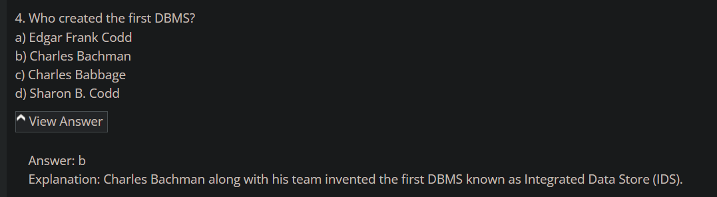

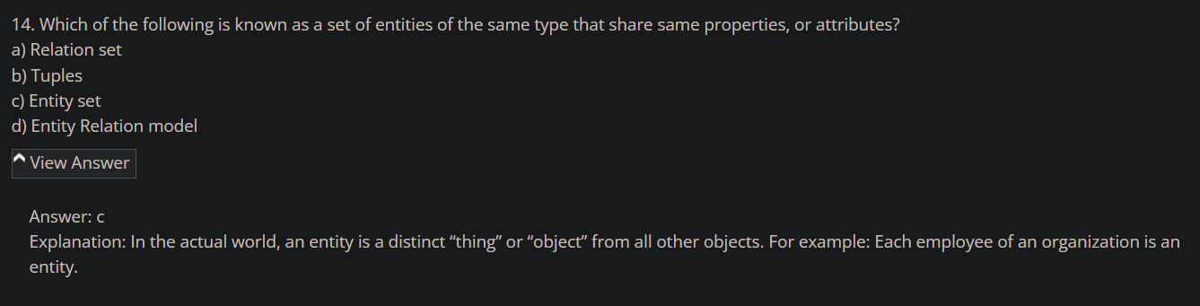

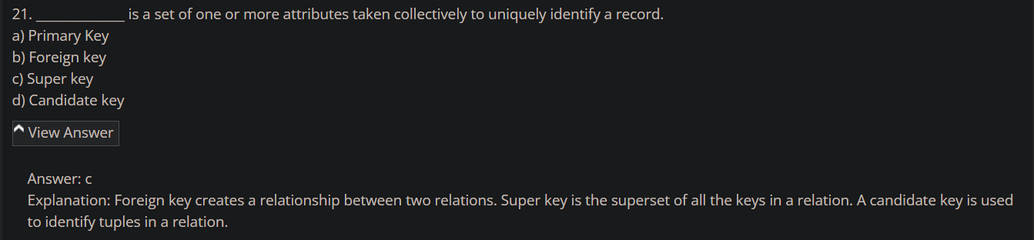

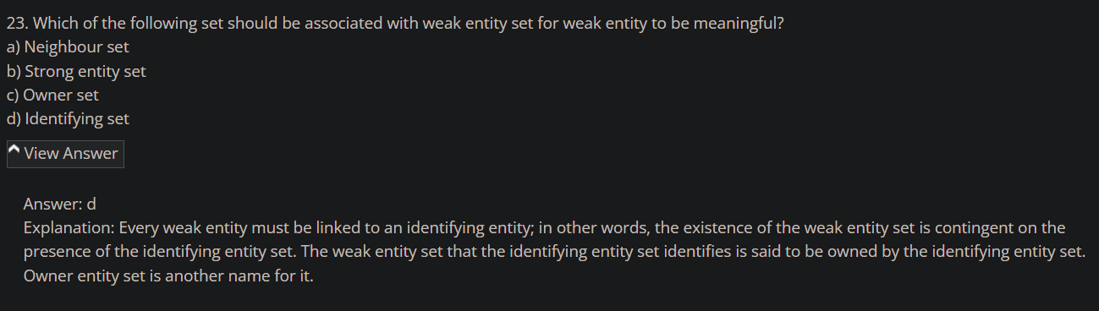

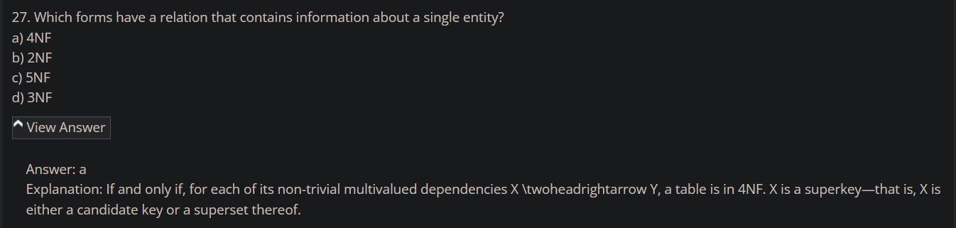

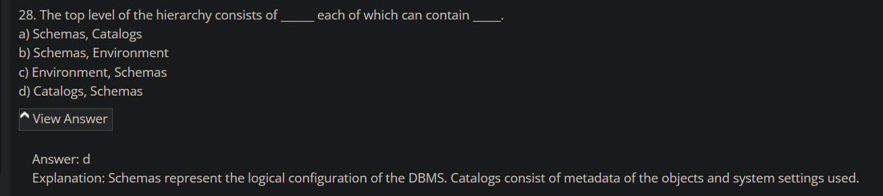

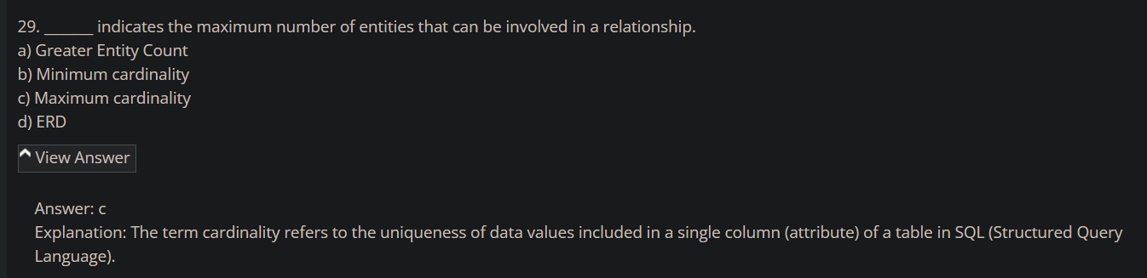

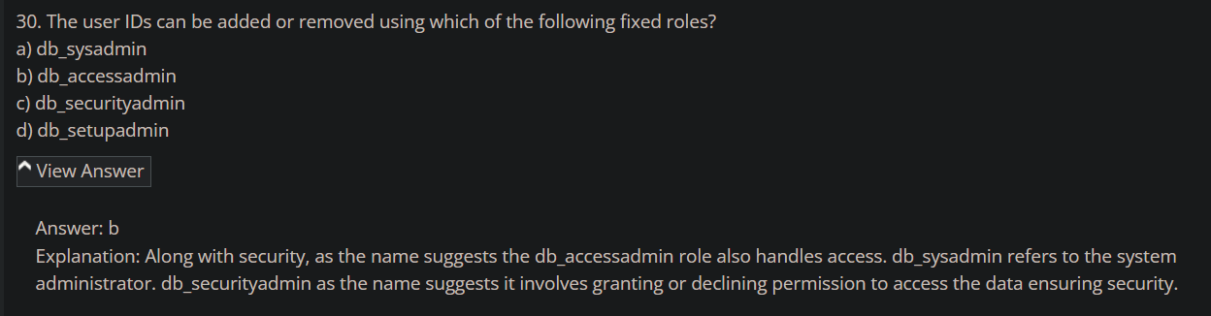

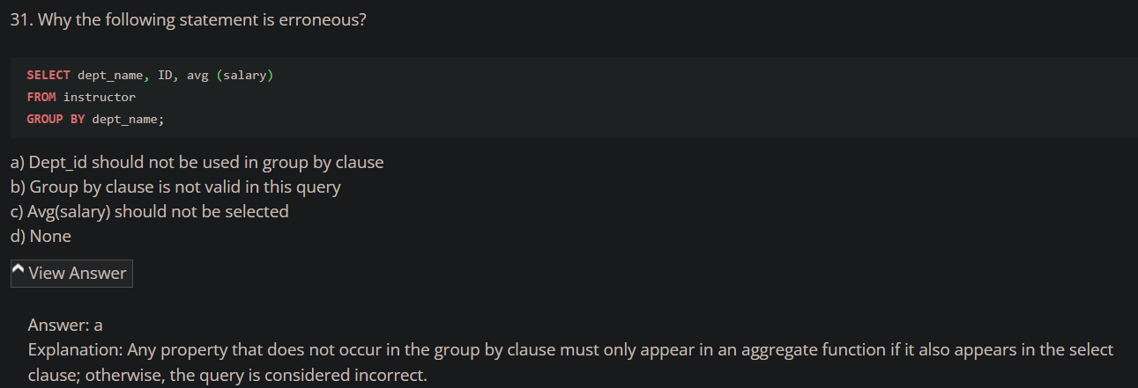

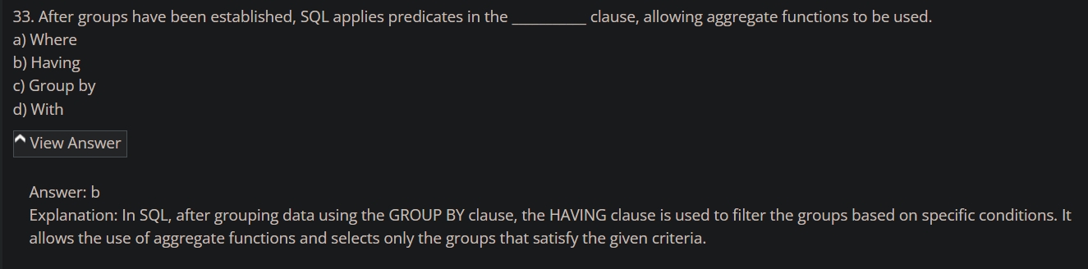

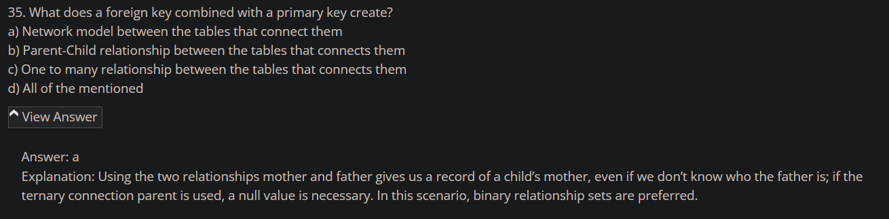

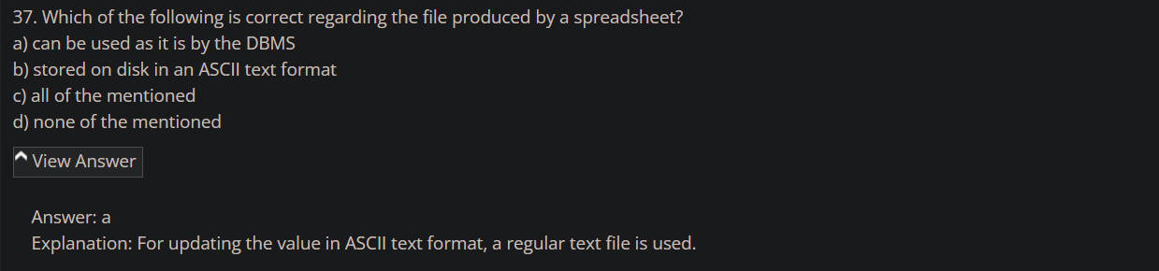

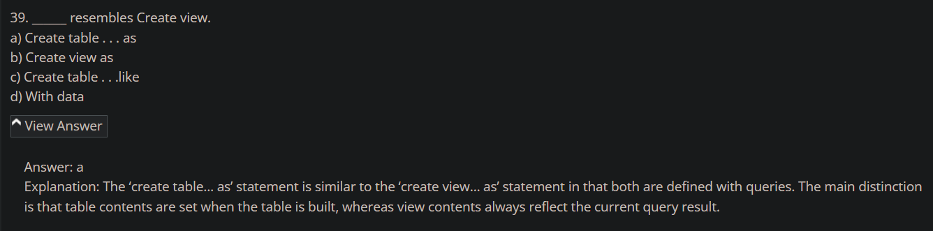

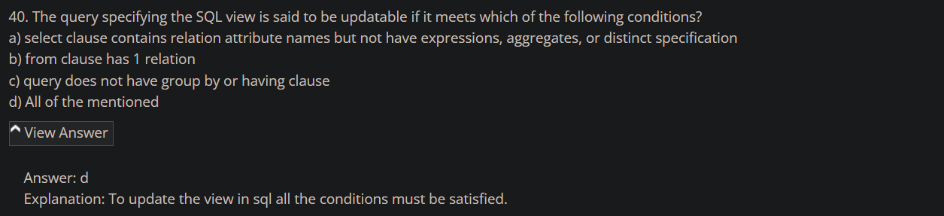

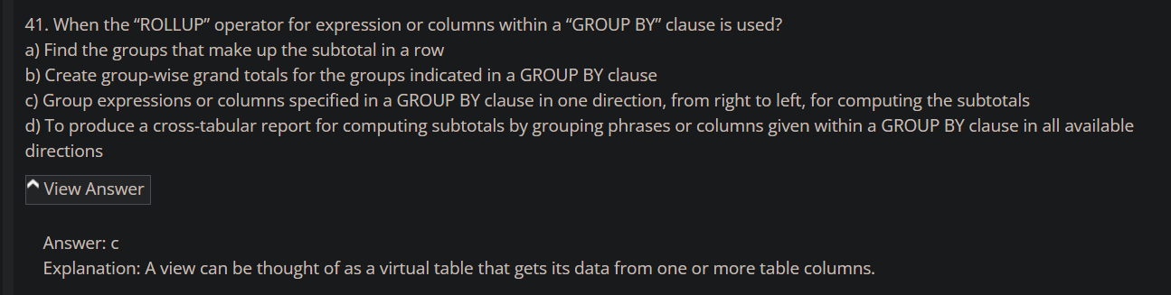

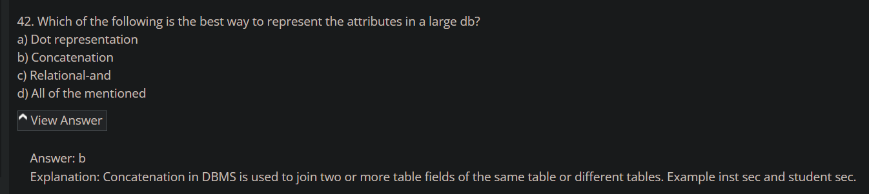

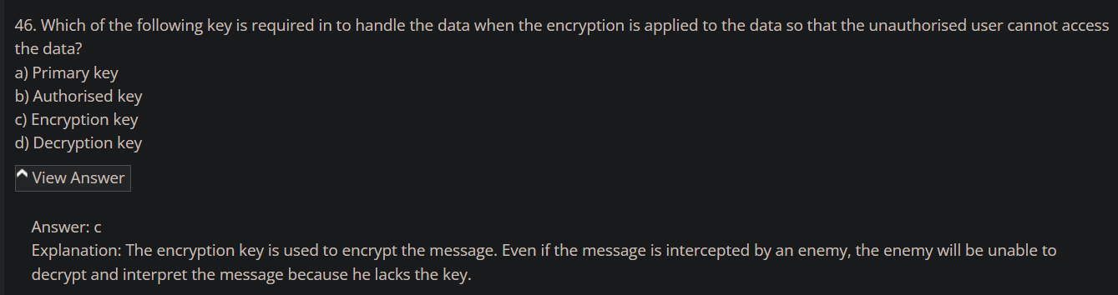

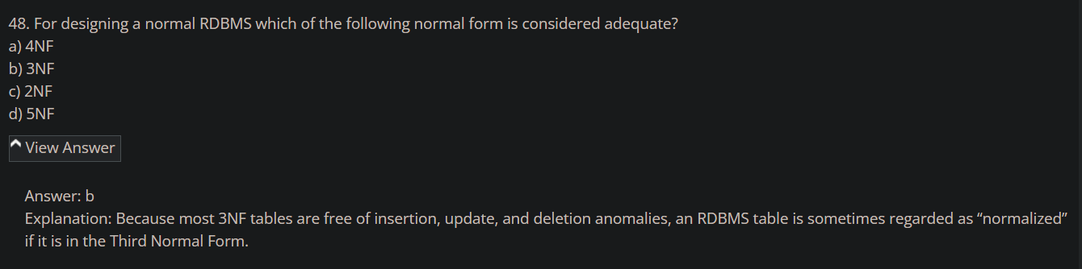

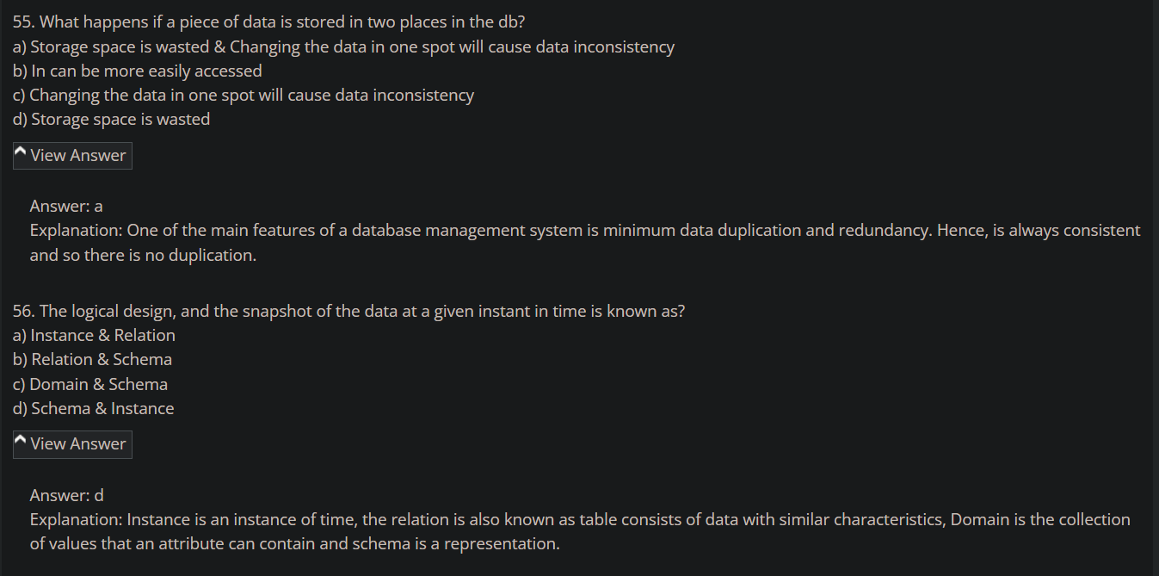

1. <https://www.sanfoundry.com/database-mcqs-relational-database-schema/>

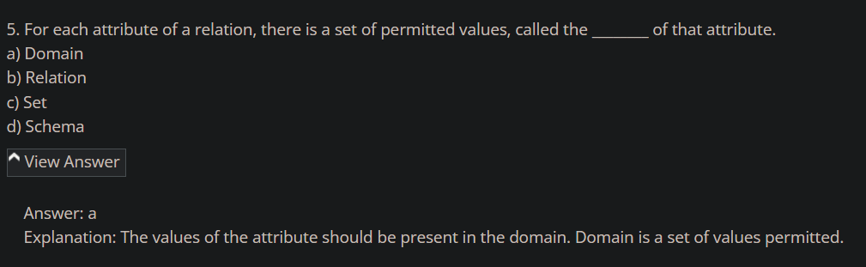

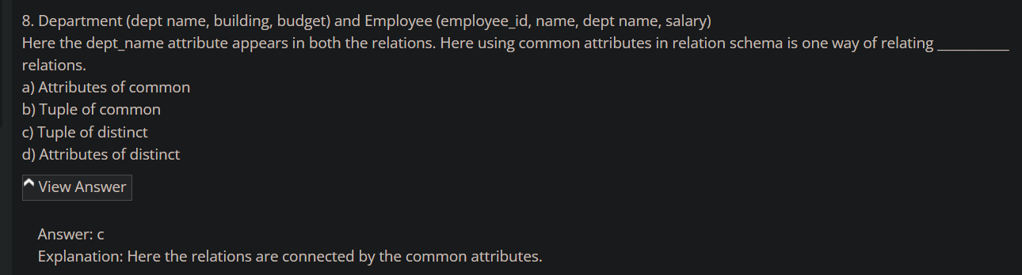

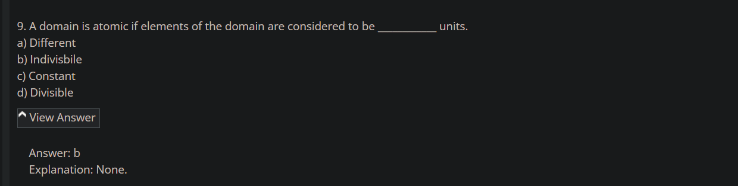

1. <https://www.sanfoundry.com/database-mcqs-keys/>

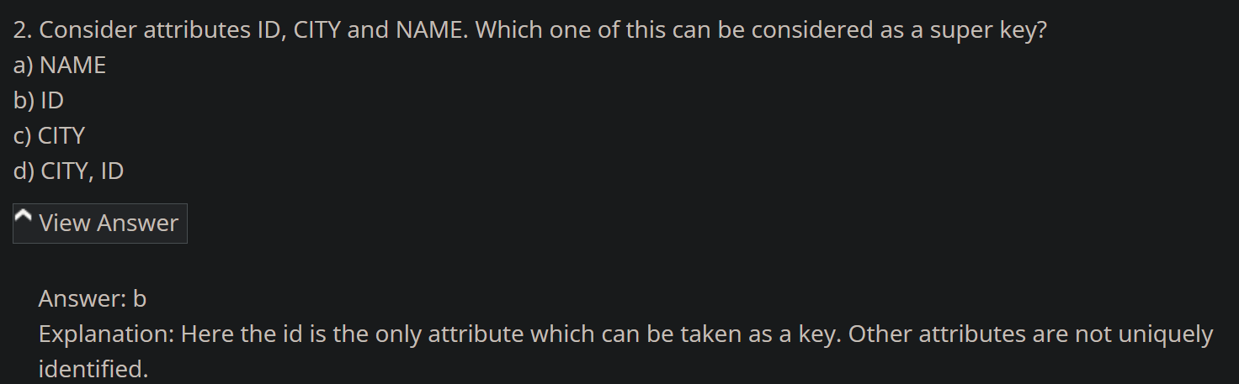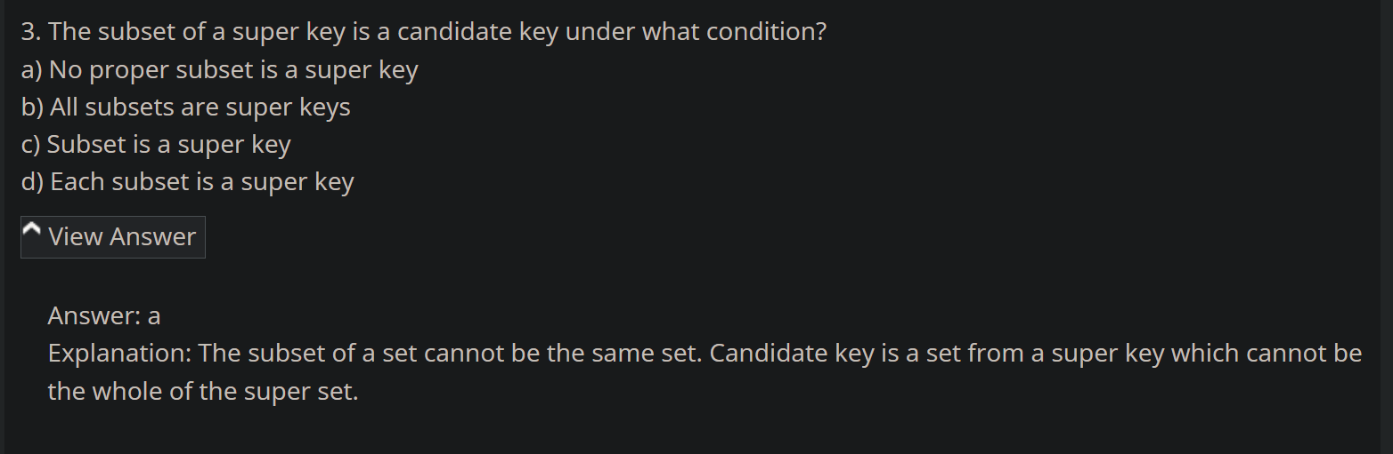

Relation =~= Table

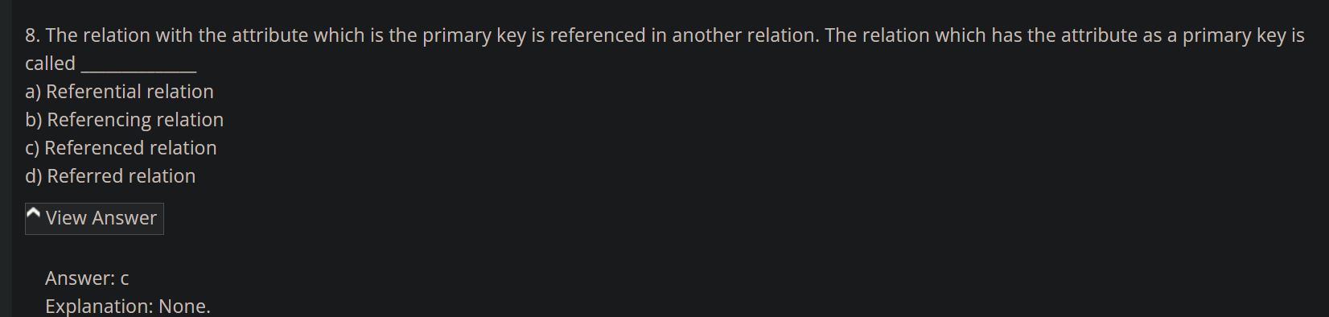

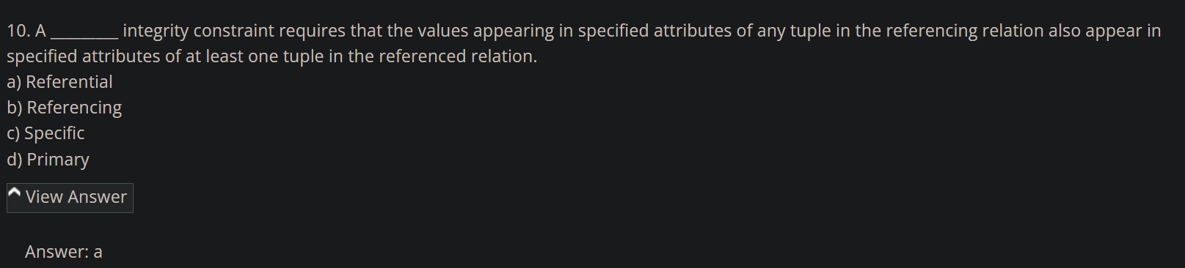

1. https://www.sanfoundry.com/database-questions-answers-mcqs/

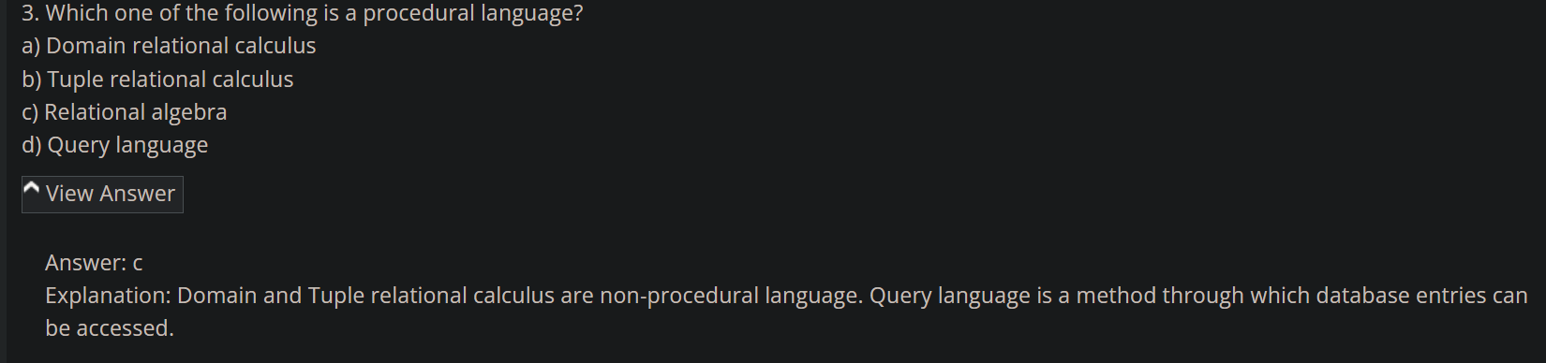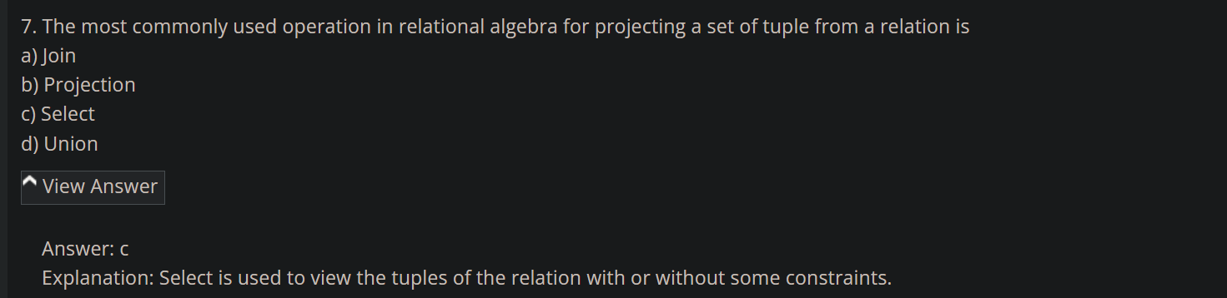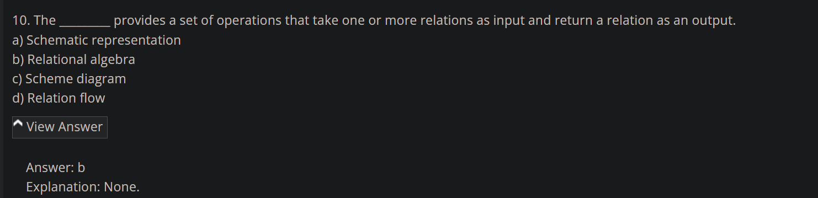

1. <https://www.sanfoundry.com/database-mcqs-sql-basics-definitions/>

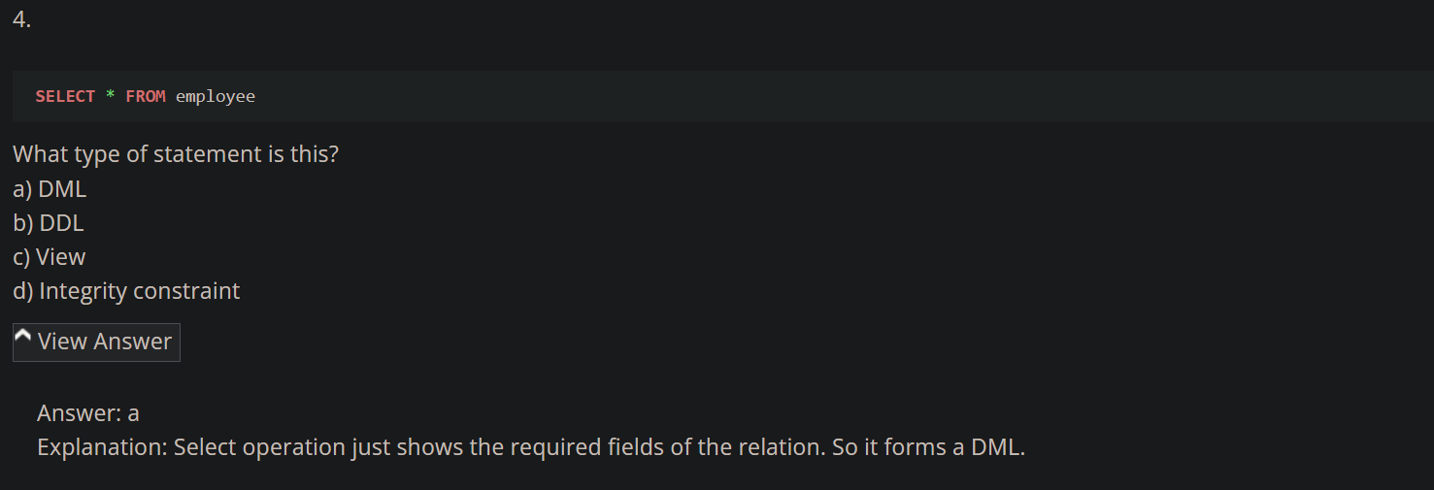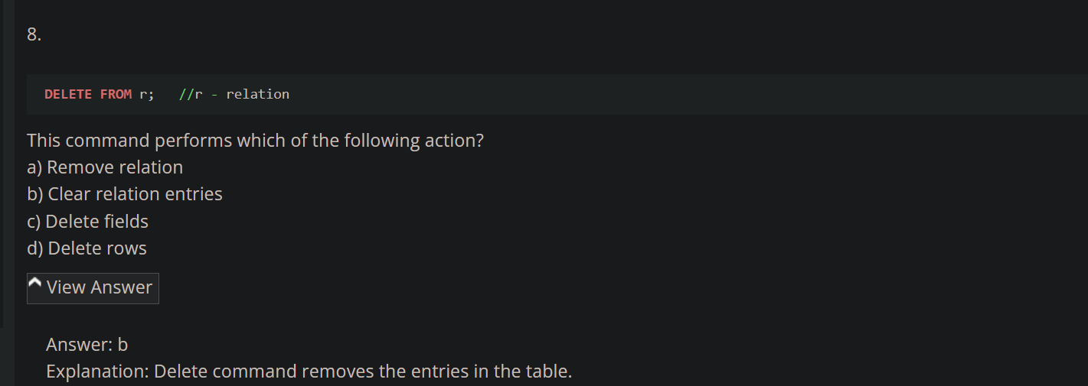

1. <https://www.sanfoundry.com/rdbms-questions-answers-sql-data-definition/>

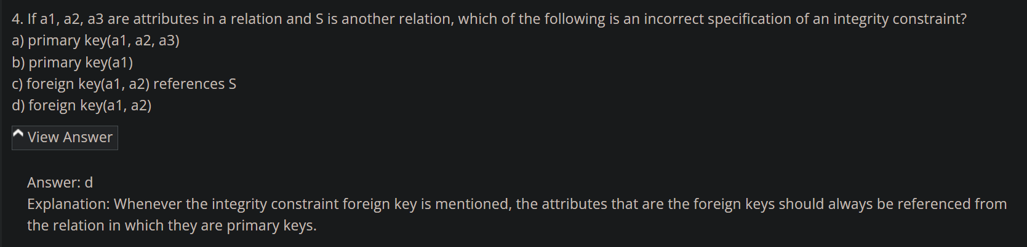

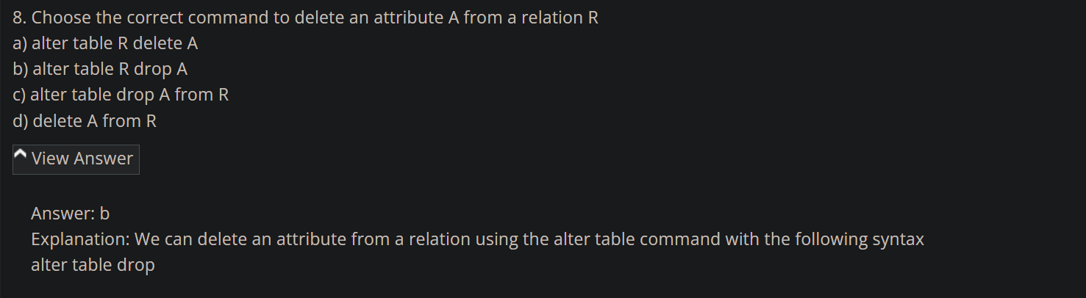

1. <https://www.interviewbit.com/rdbms-mcq/>

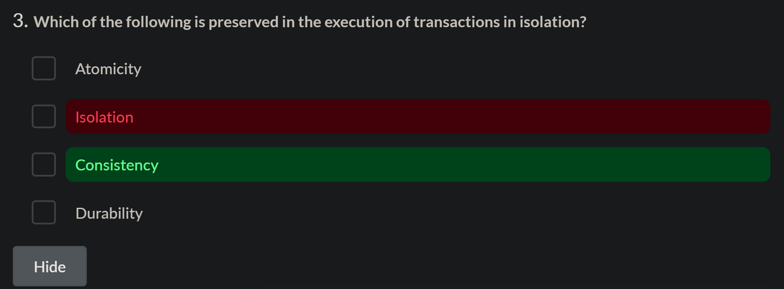

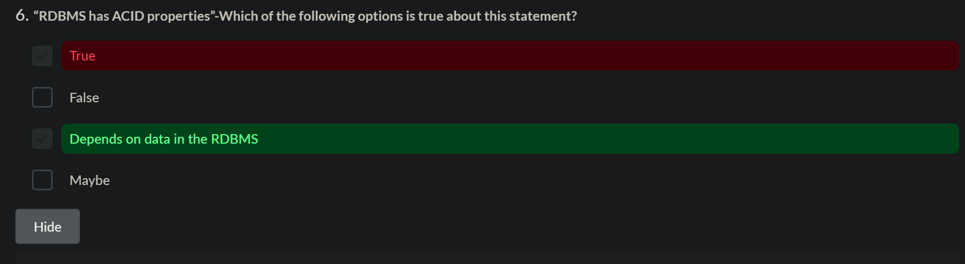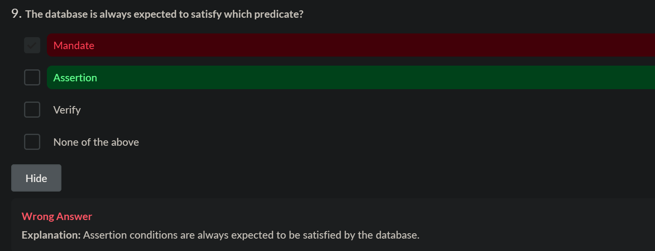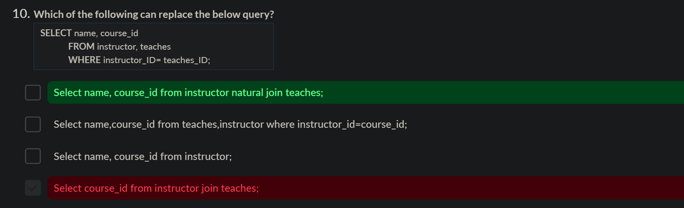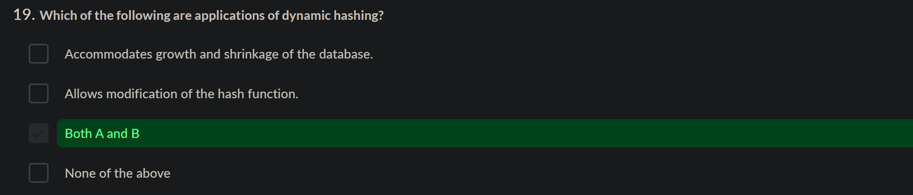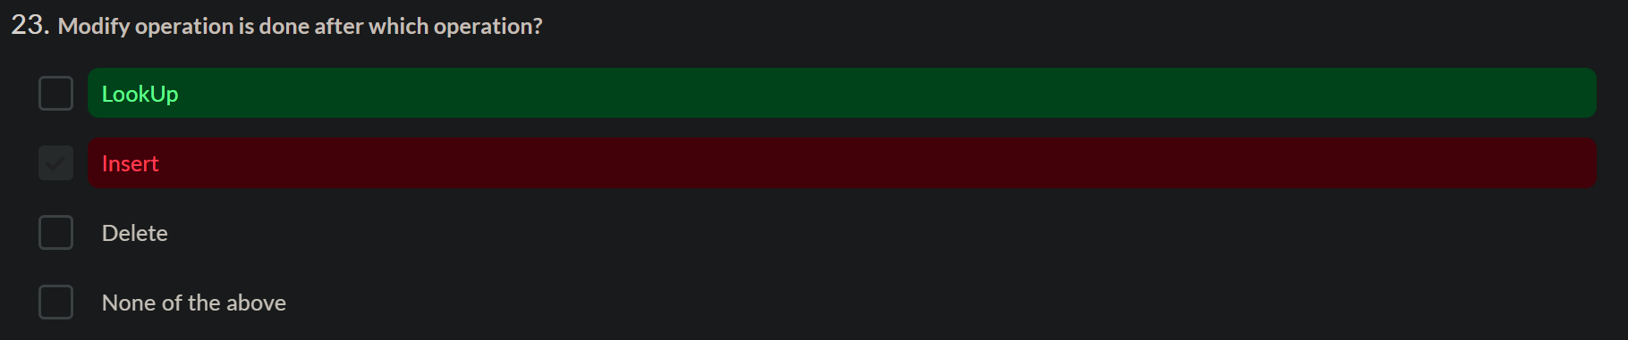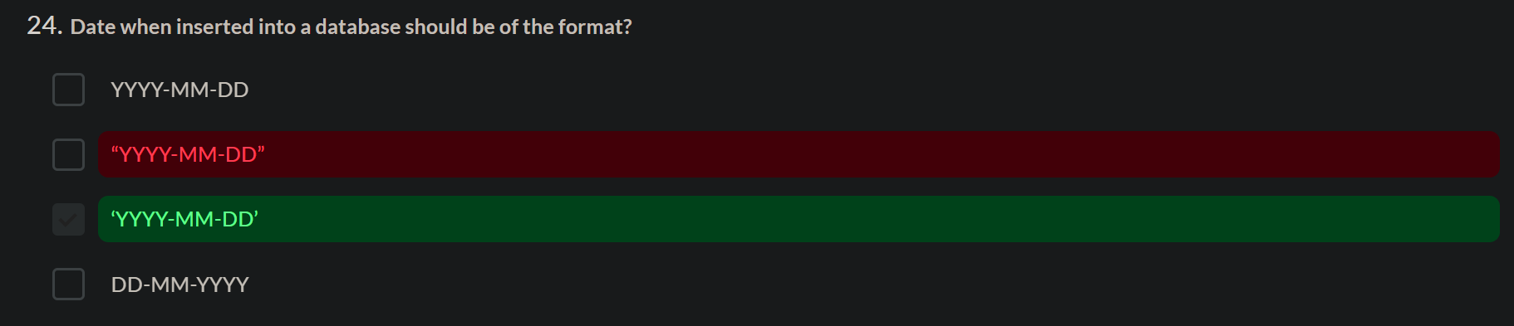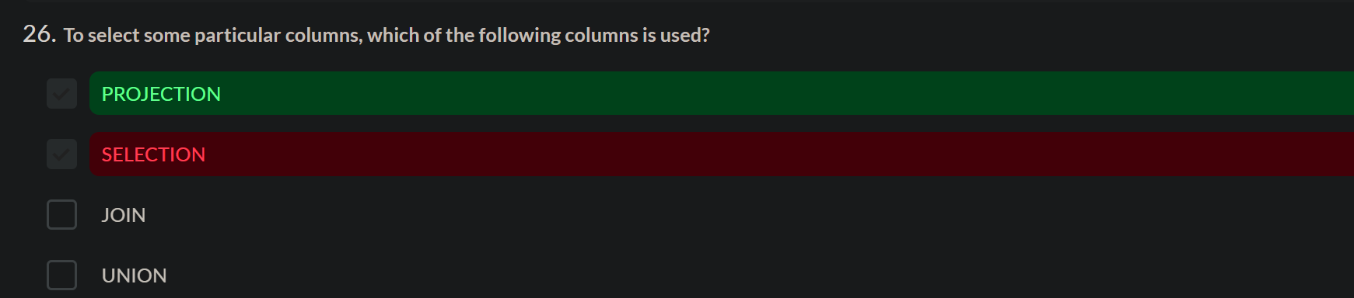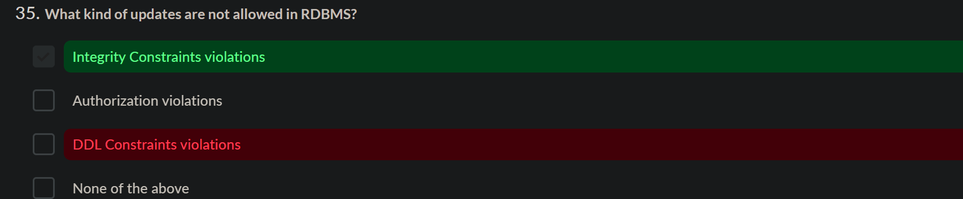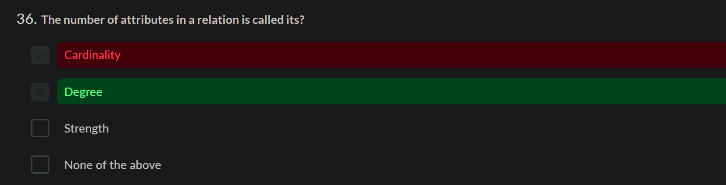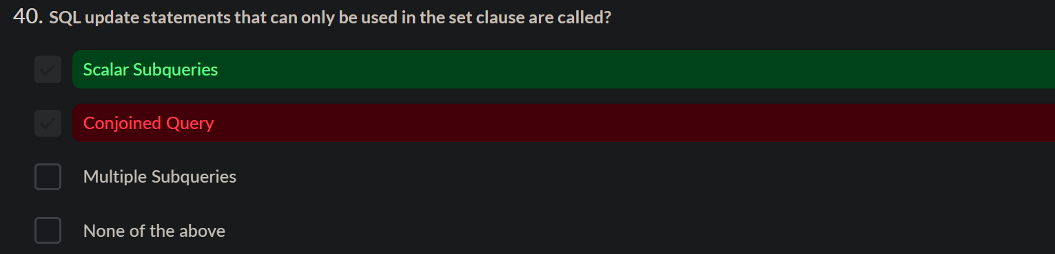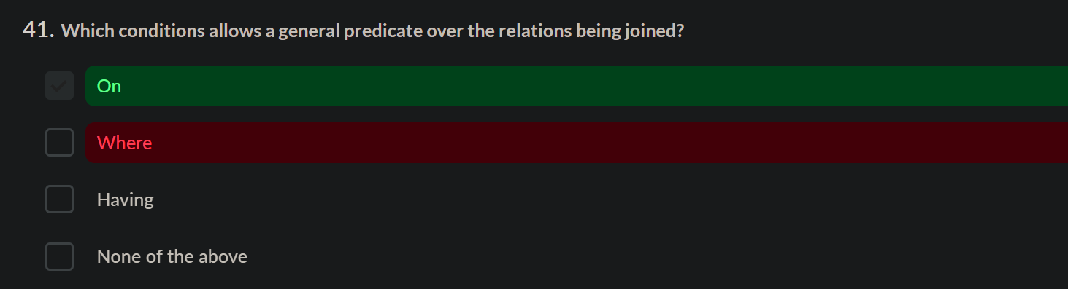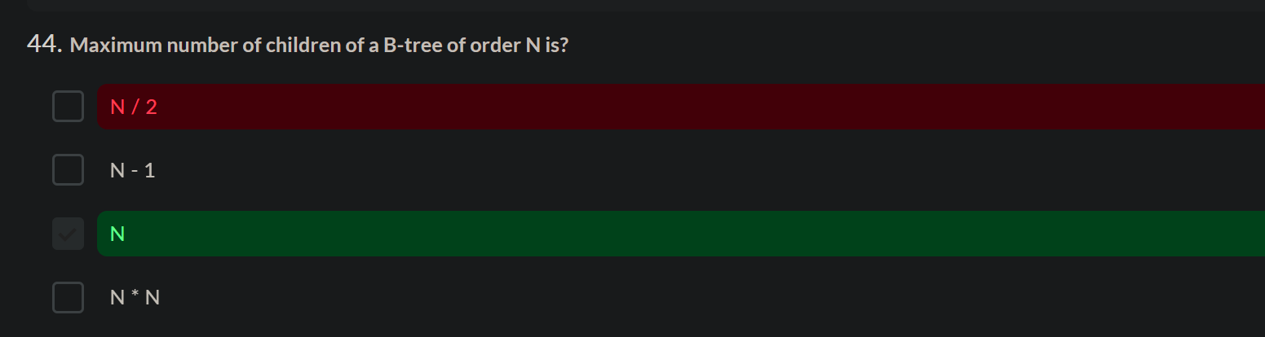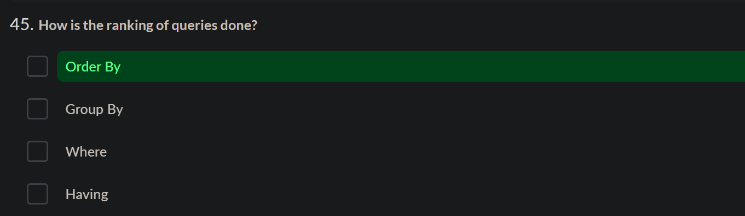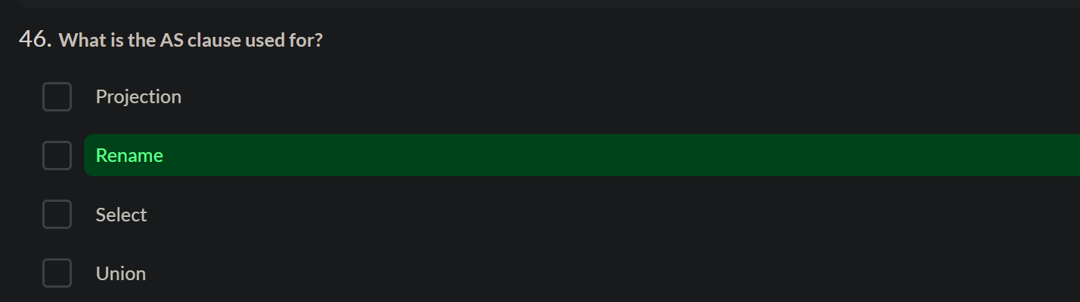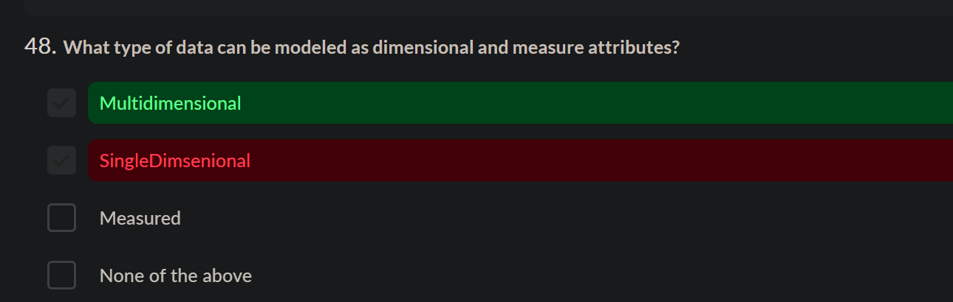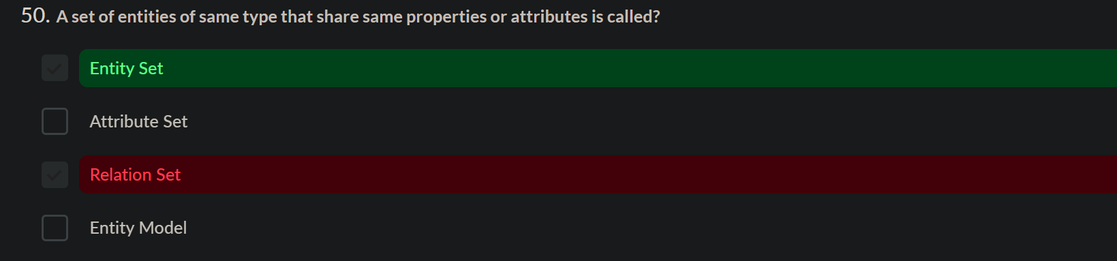

To calculate date of birth

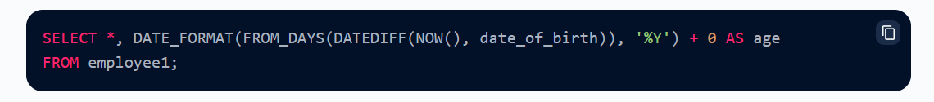

**1-1-2024**

1. <https://www.sanfoundry.com/rdbms-questions-answers-introduction-relational-model/>

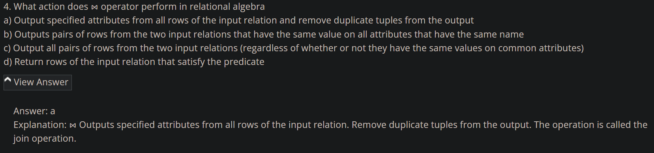

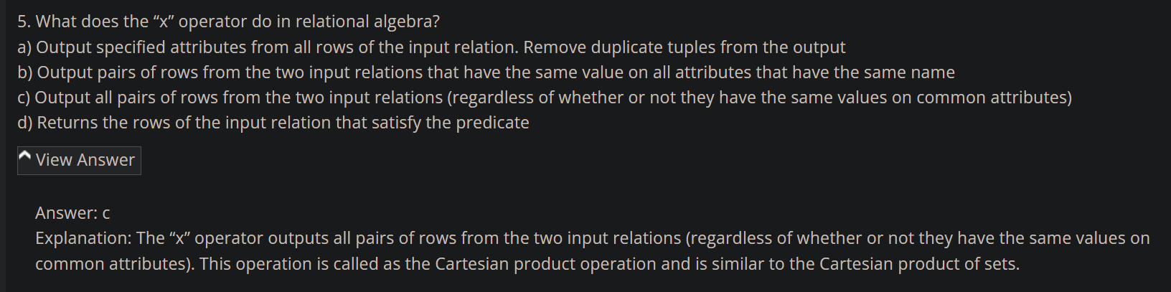

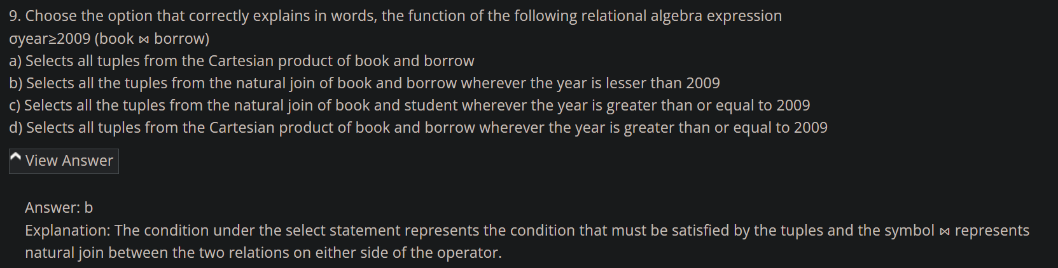

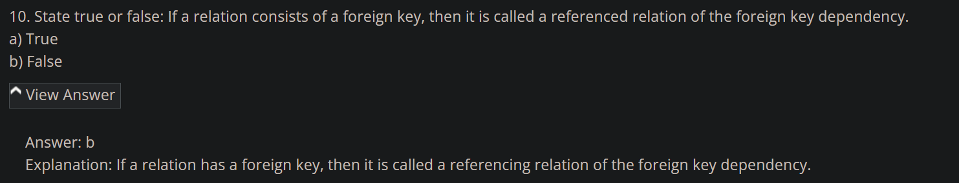

1. <https://www.sanfoundry.com/rdbms-questions-answers-basic-operations/>

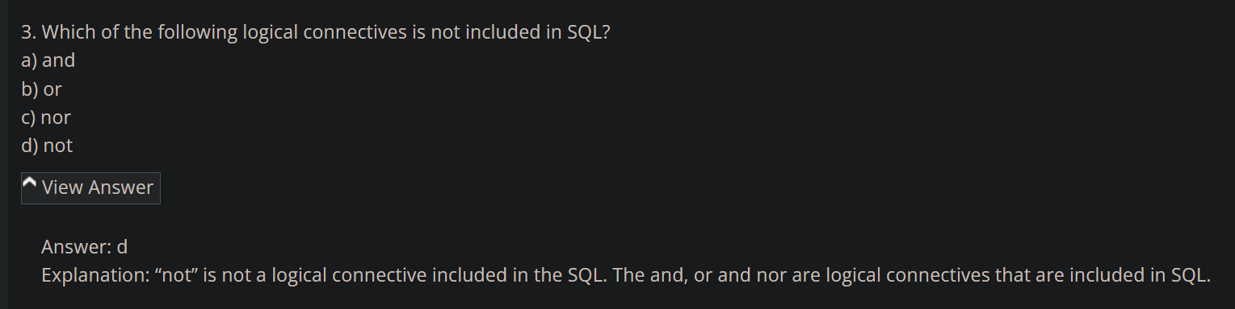

1. <https://www.sanfoundry.com/rdbms-questions-answers-set-operations/>

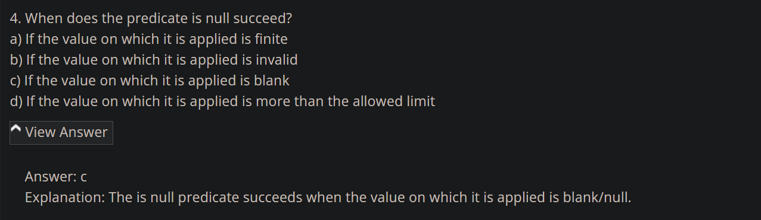

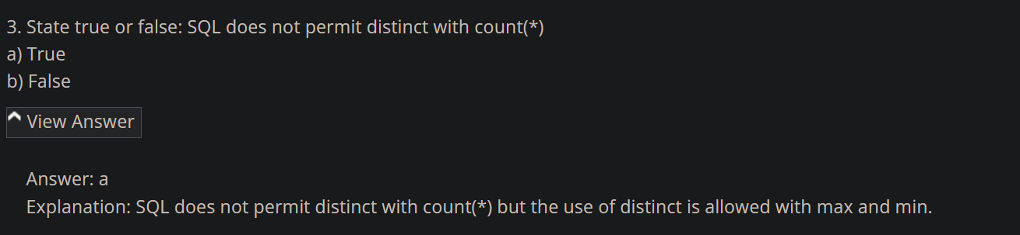

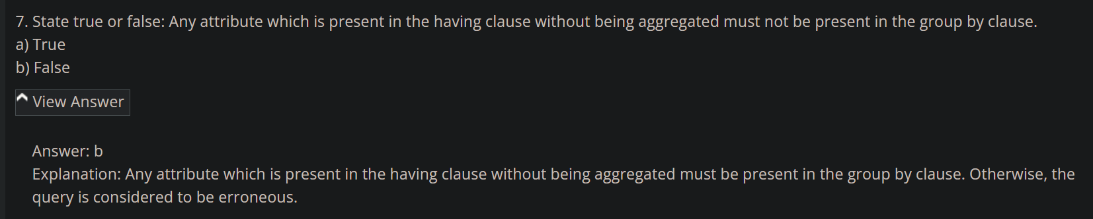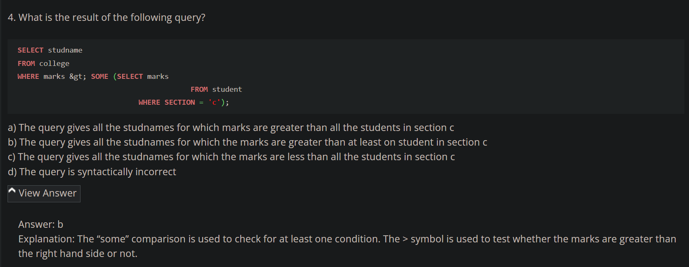

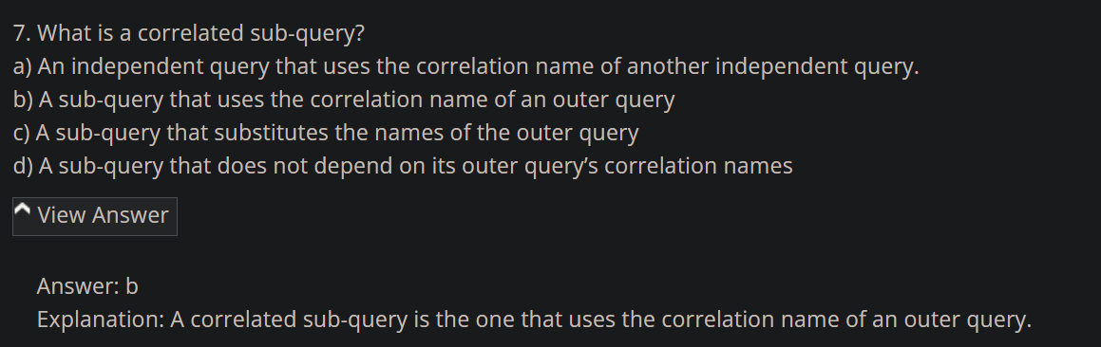

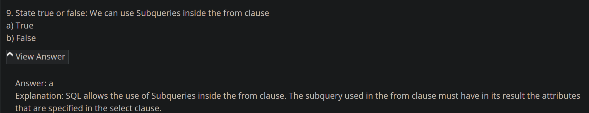

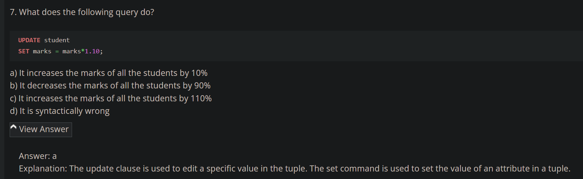

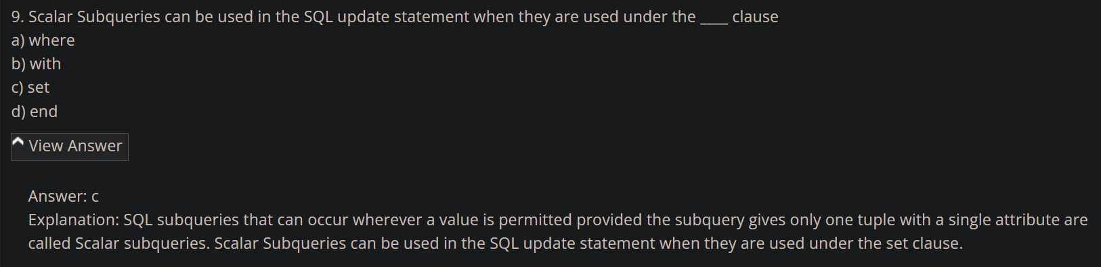

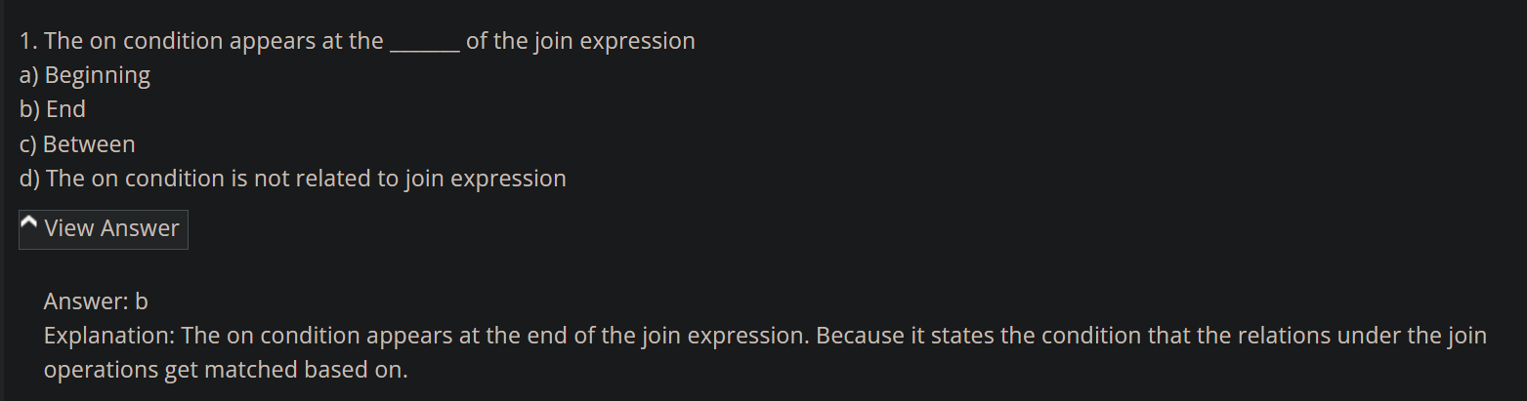

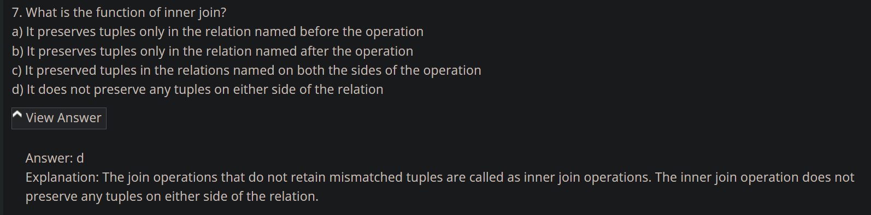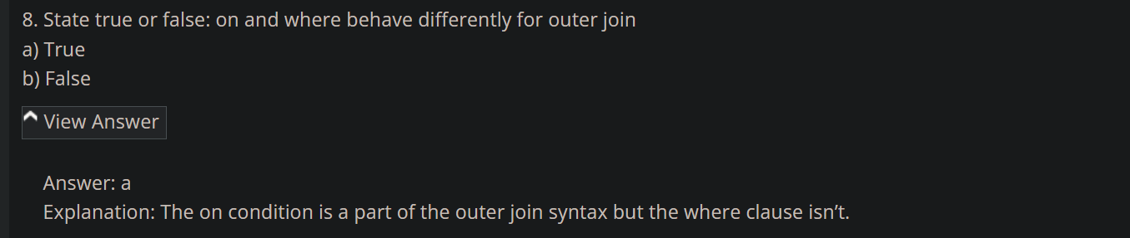

<https://www.sanfoundry.com/rdbms-questions-answers-views-transactions/>



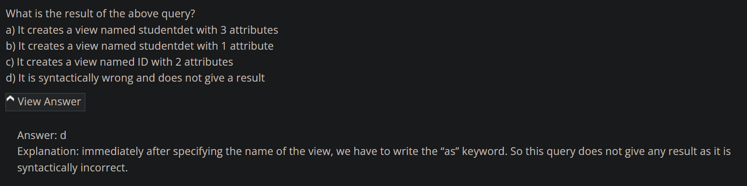

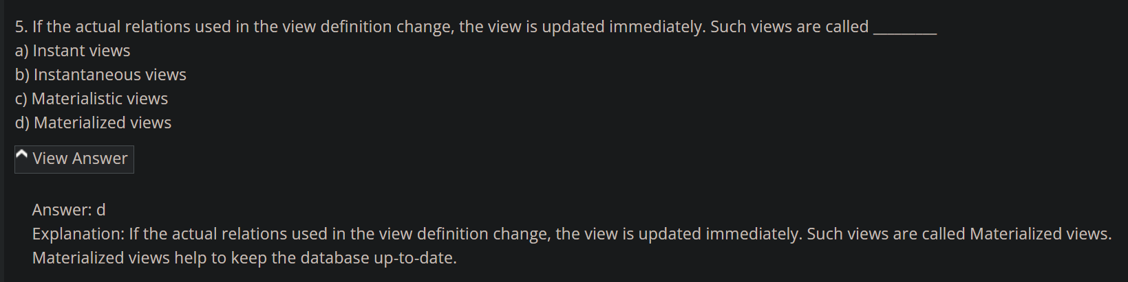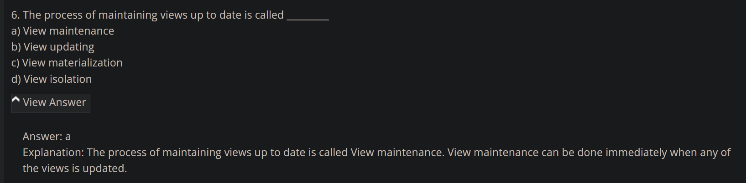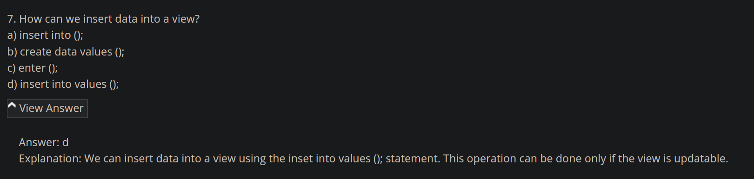

<https://www.sanfoundry.com/rdbms-questions-answers-integrity-constraints/>

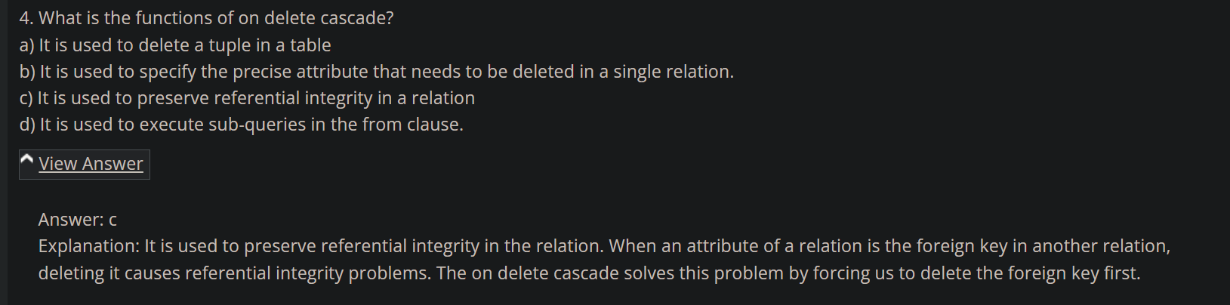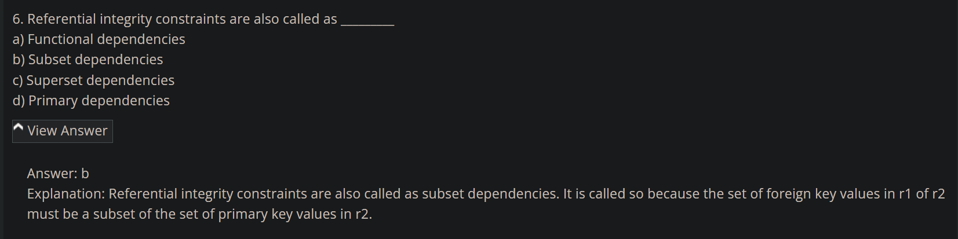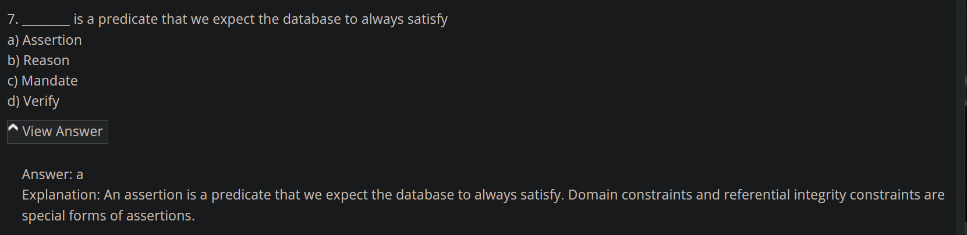

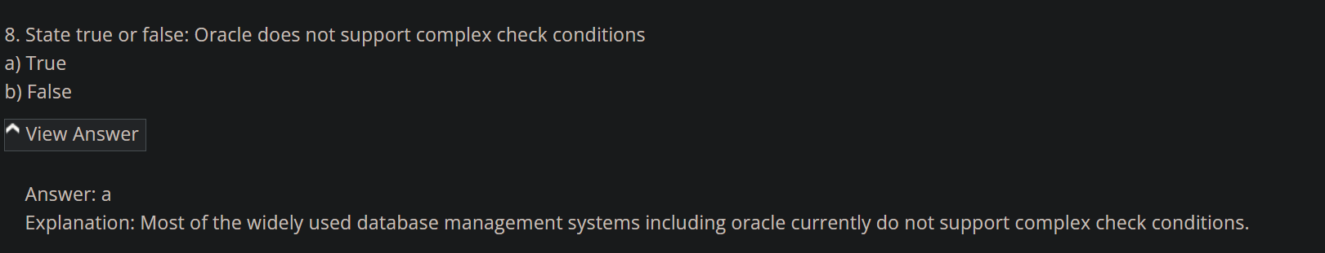

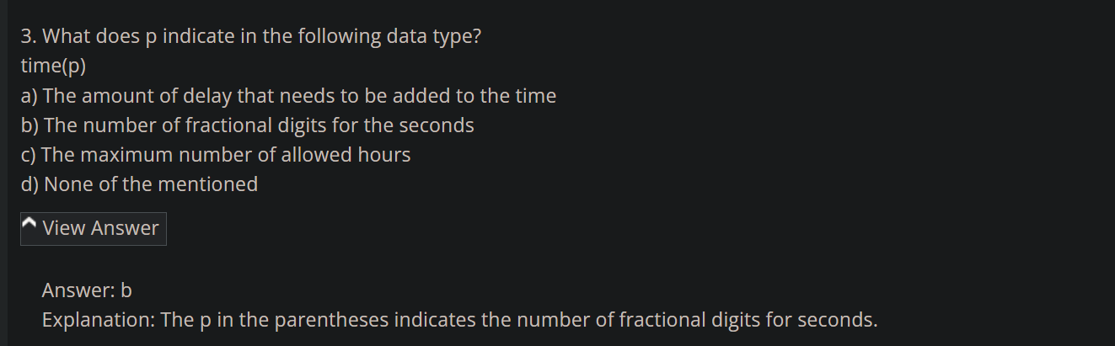

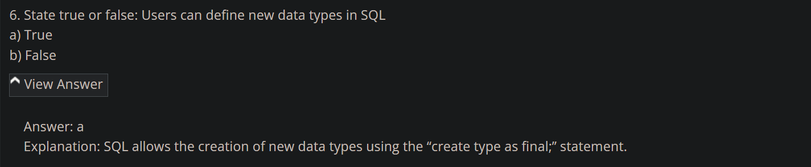

<https://www.sanfoundry.com/rdbms-interview-questions-answers-freshers/>

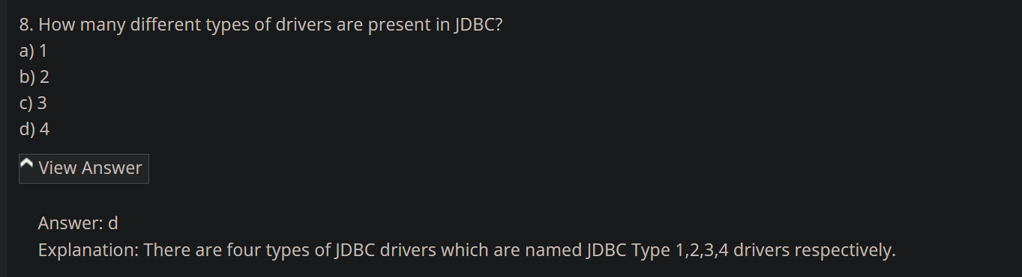

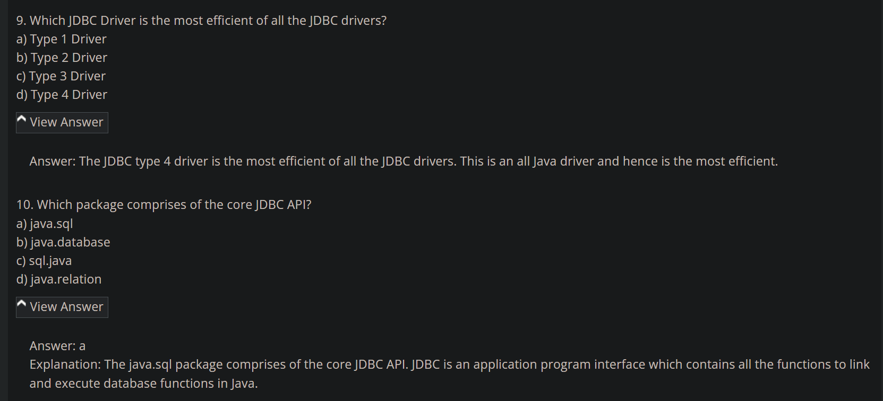

<https://www.sanfoundry.com/rdbms-questions-answers-experienced/>

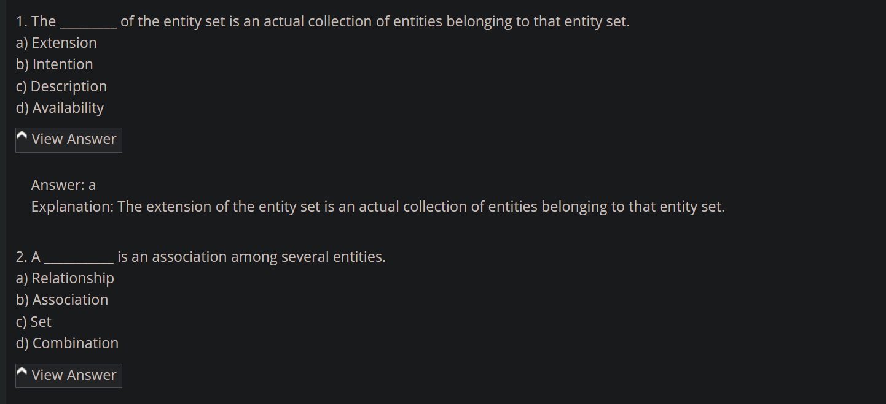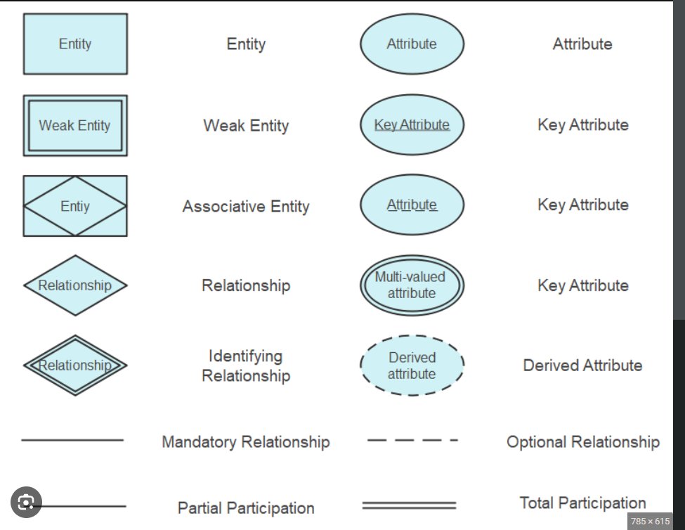

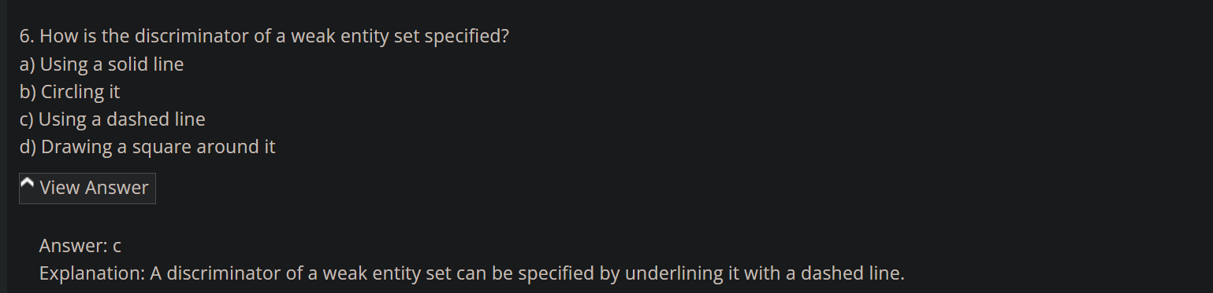

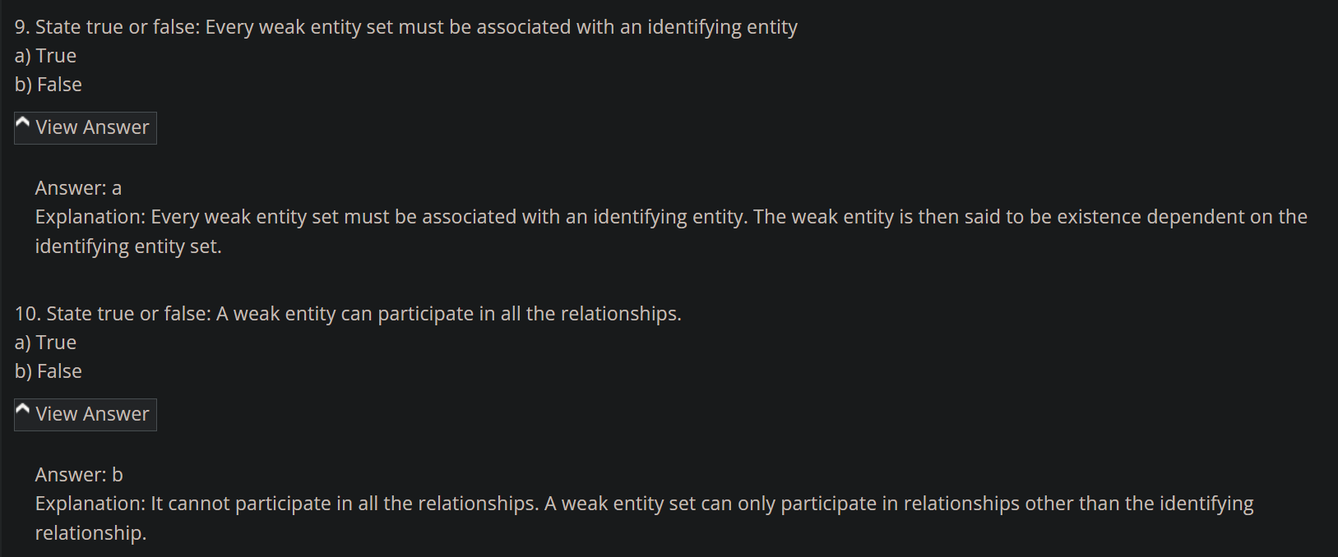

**MYSQL**

<https://www.sanfoundry.com/mysql-questions-answers-basic-database-terminology/>

<https://www.sanfoundry.com/mysql-questions-answers-interacting-mysql/>

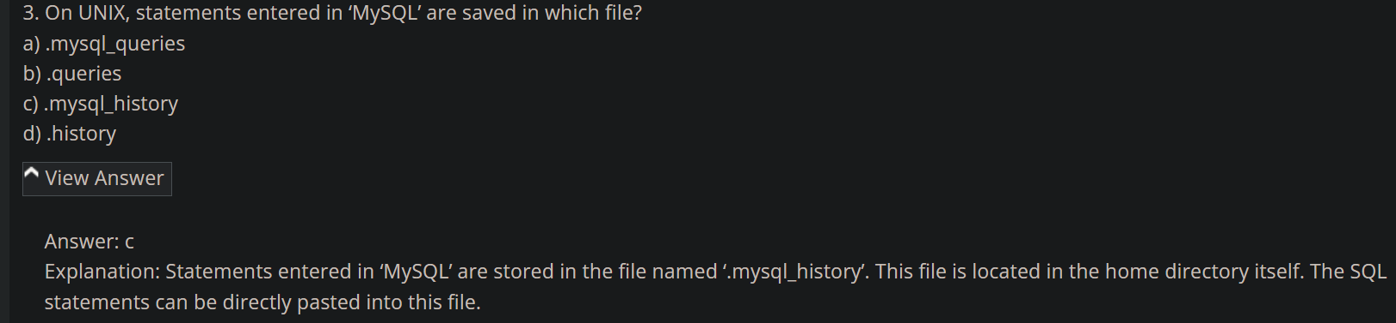

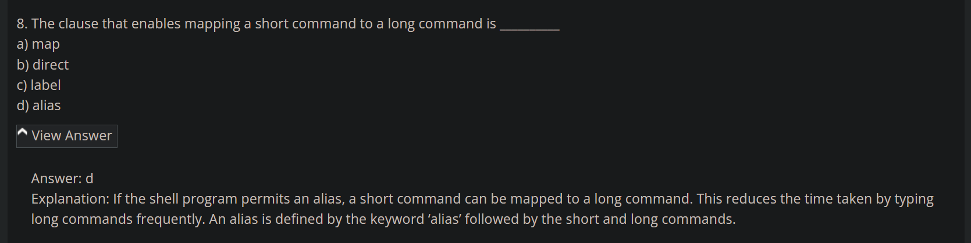

<https://www.sanfoundry.com/mysql-questions-answers-server-sql-mode/#google_vignette>

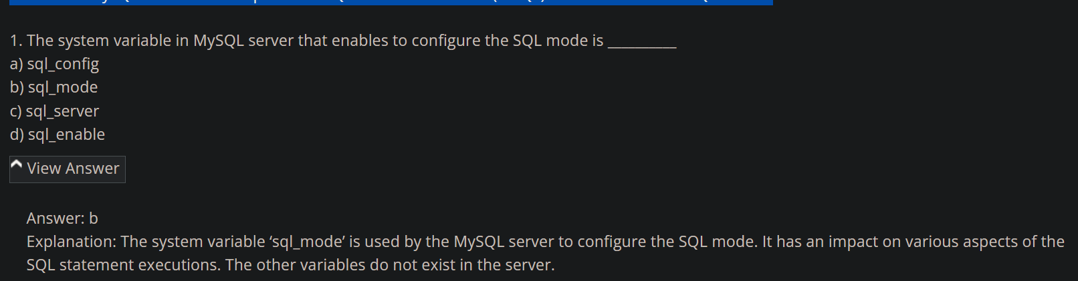

<https://www.sanfoundry.com/mysql-questions-answers-freshers/>

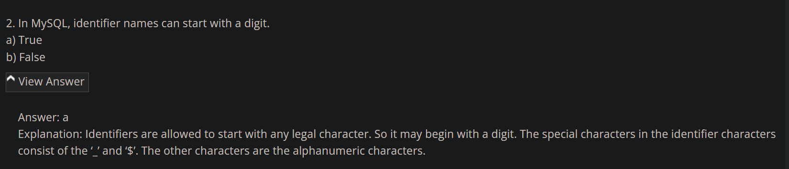

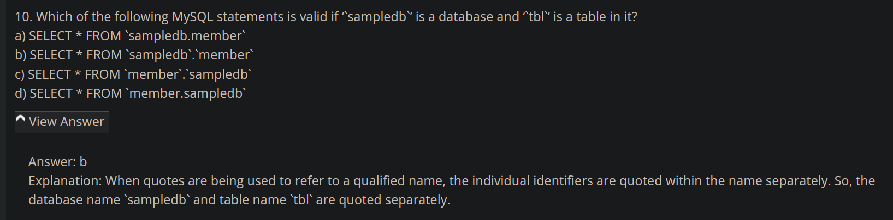

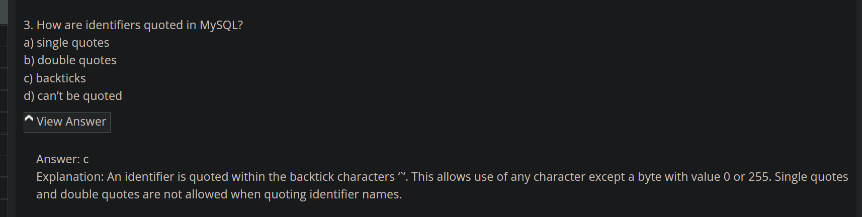

<https://www.sanfoundry.com/mysql-questions-answers-using-views/#google_vignette>

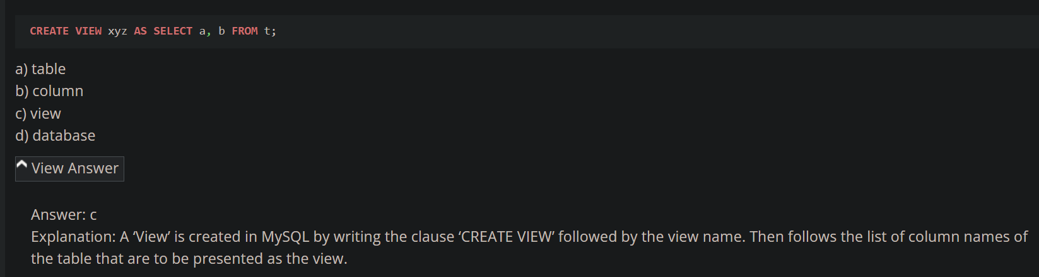

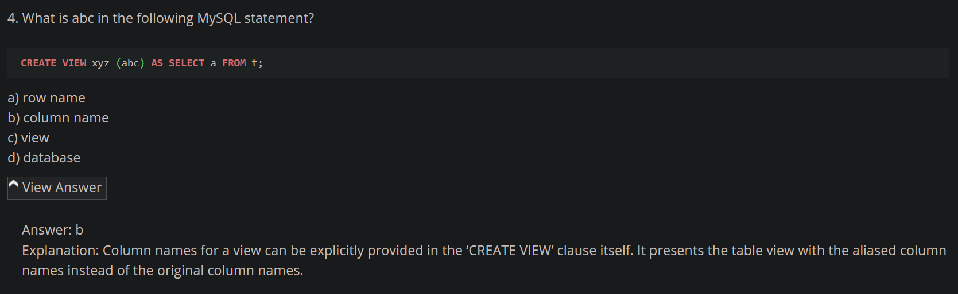

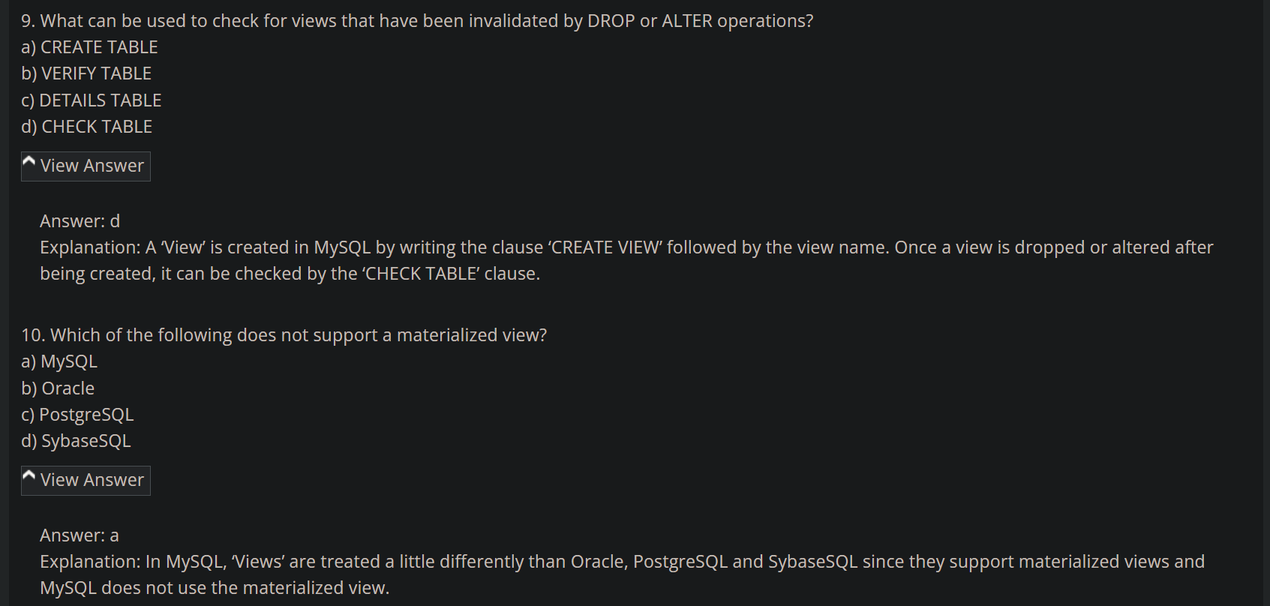

<https://www.sanfoundry.com/sql-mcqs-mysql-datatypes-1/>

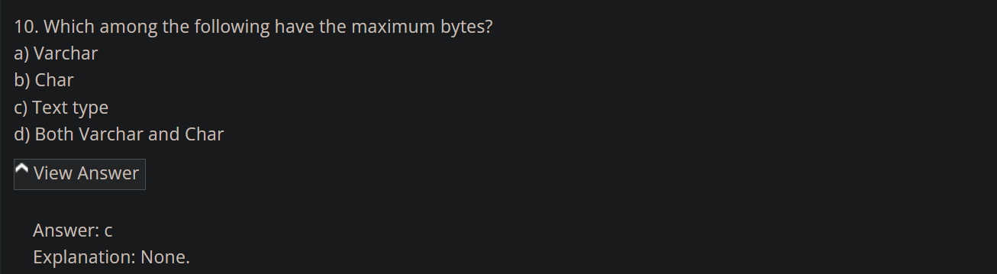

<https://www.sanfoundry.com/sql-mcqs-mysql-datatypes-2/>

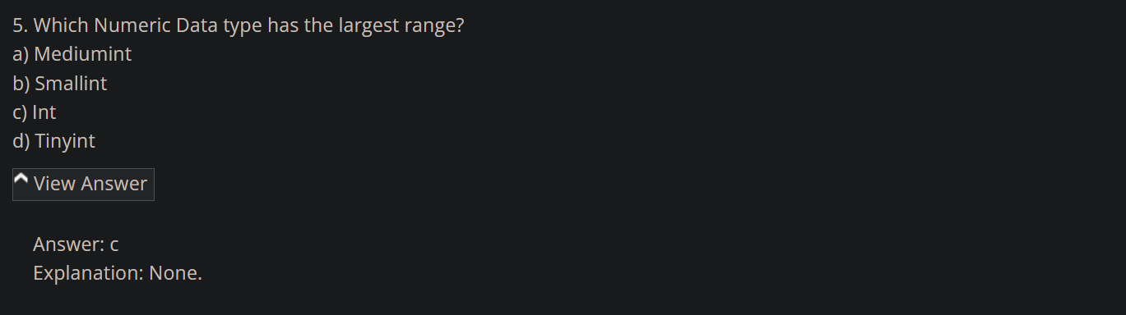

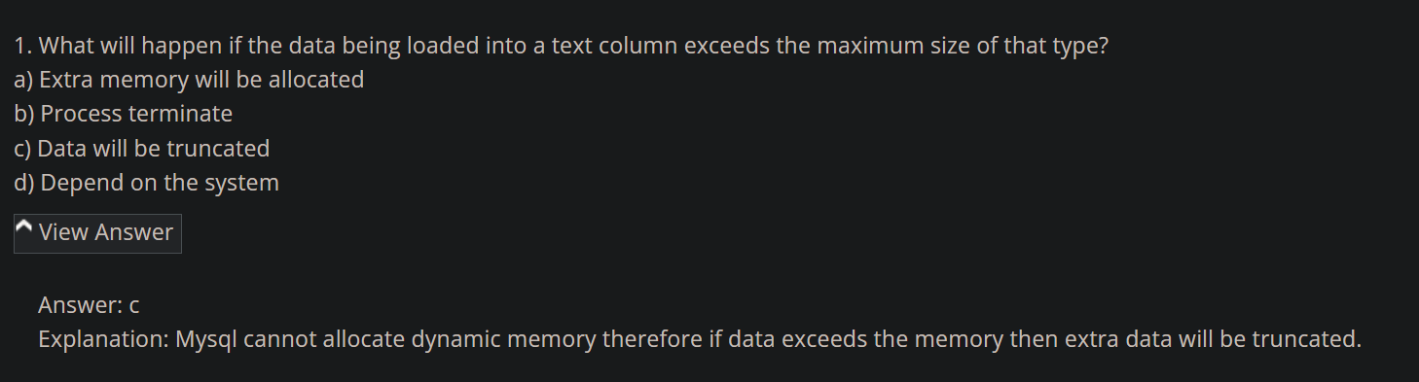

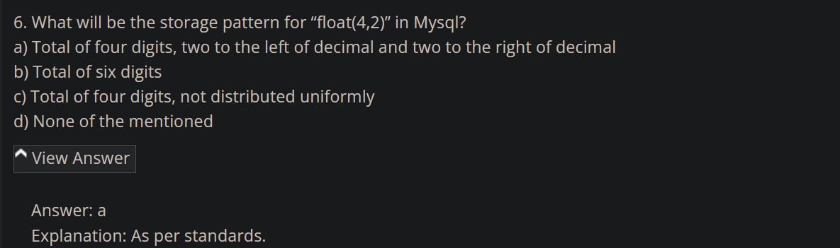

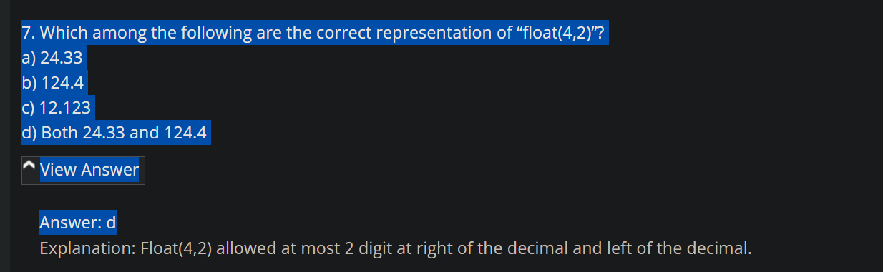

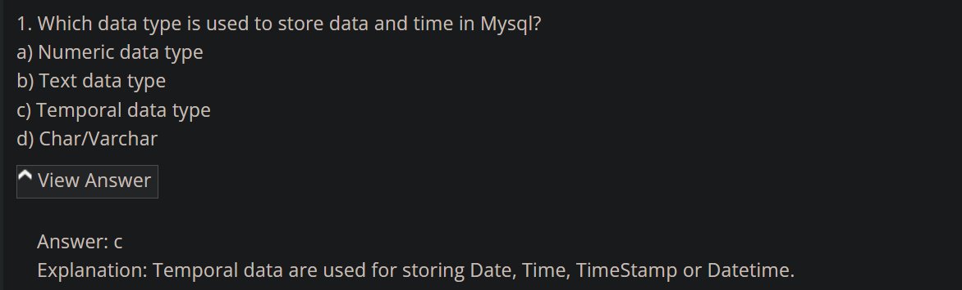

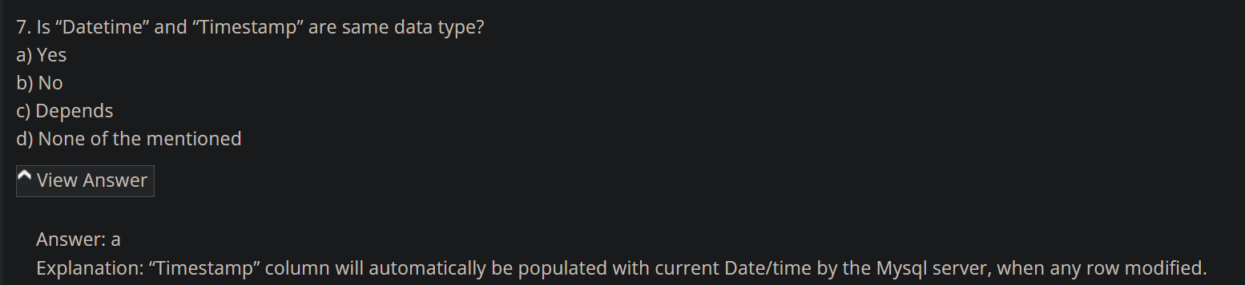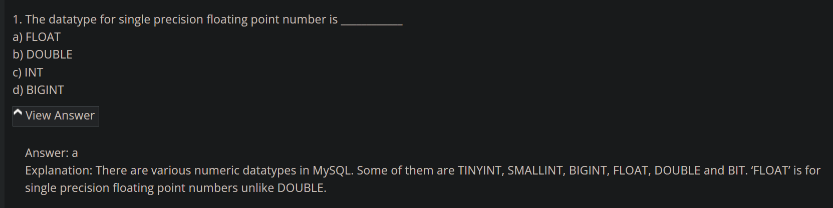

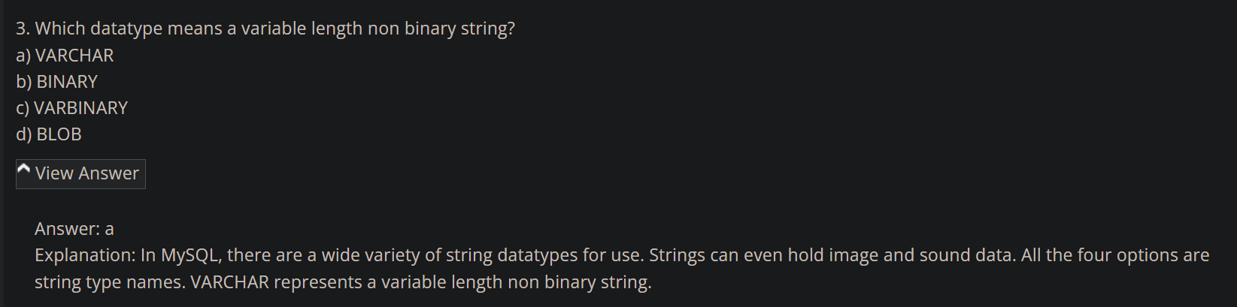

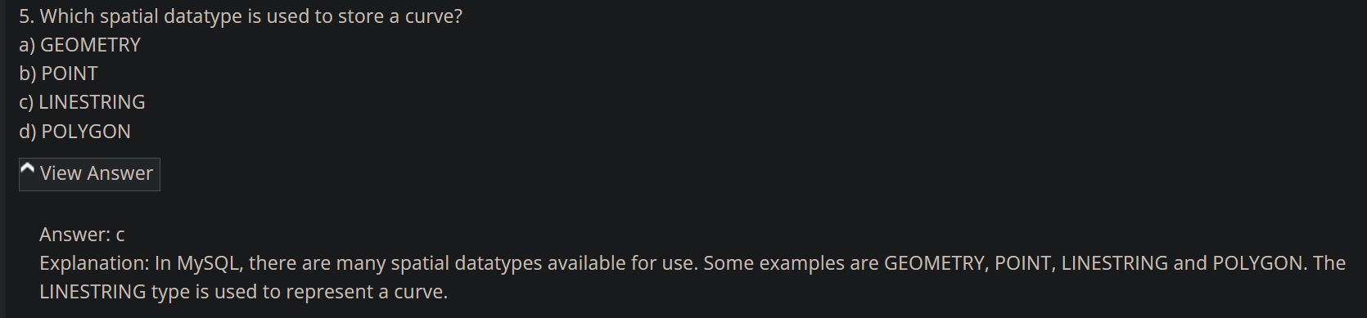

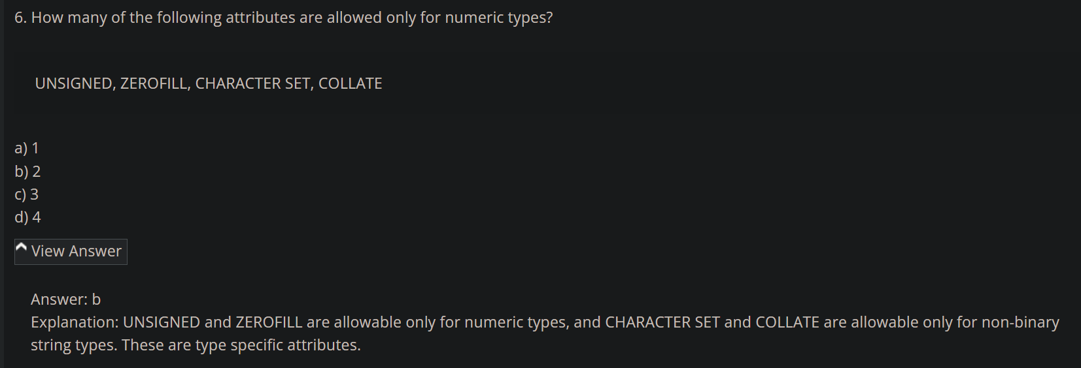

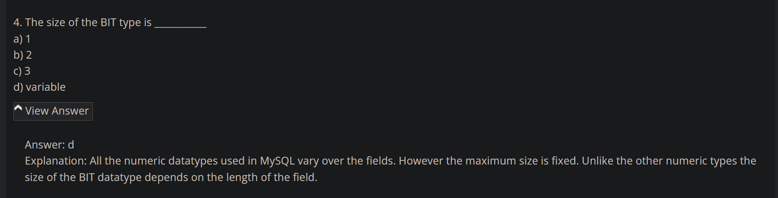

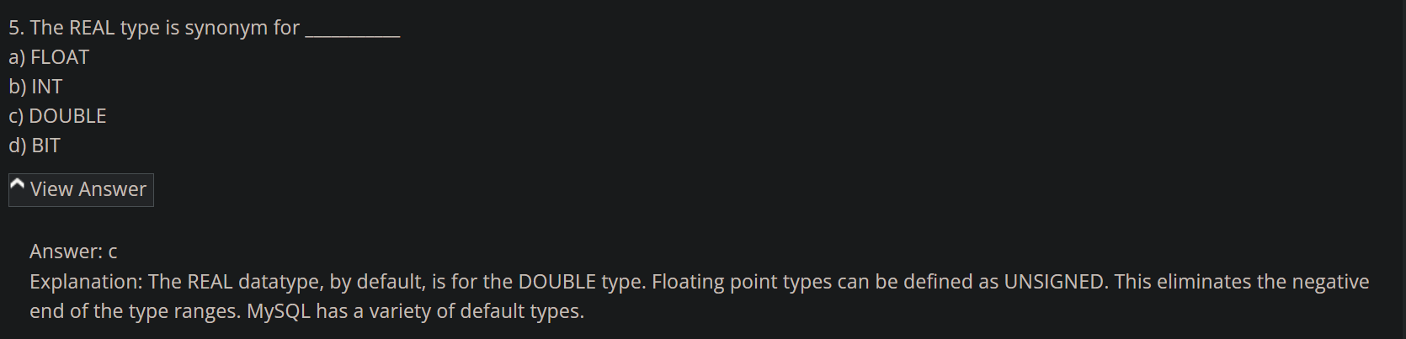

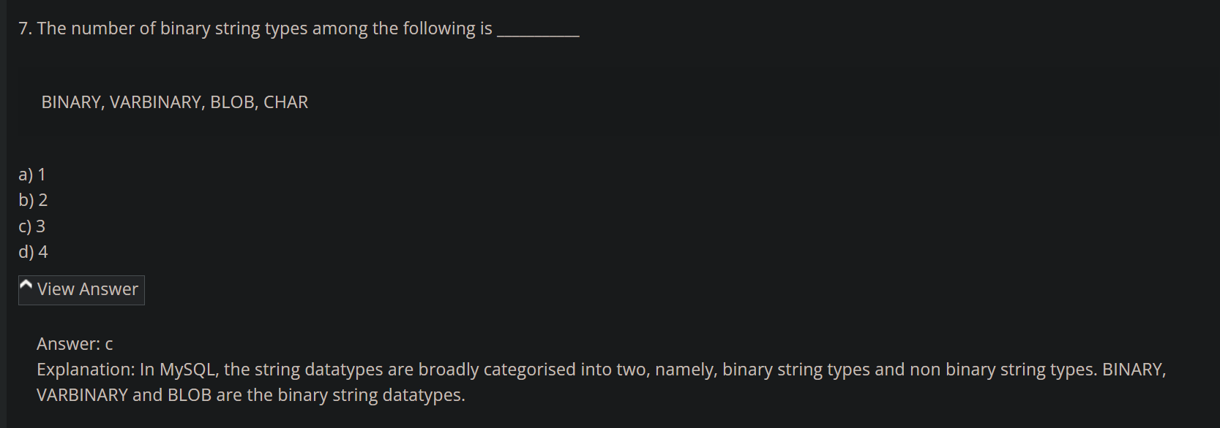

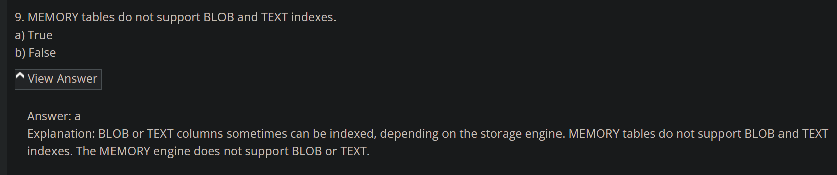

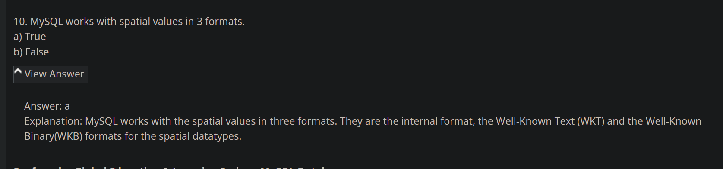

<https://www.sanfoundry.com/mysql-questions-answers-online-quiz/>

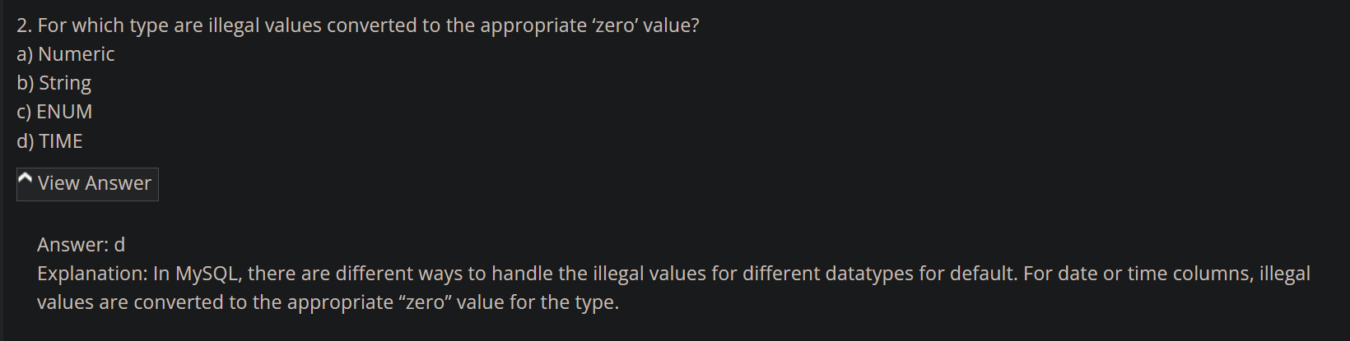

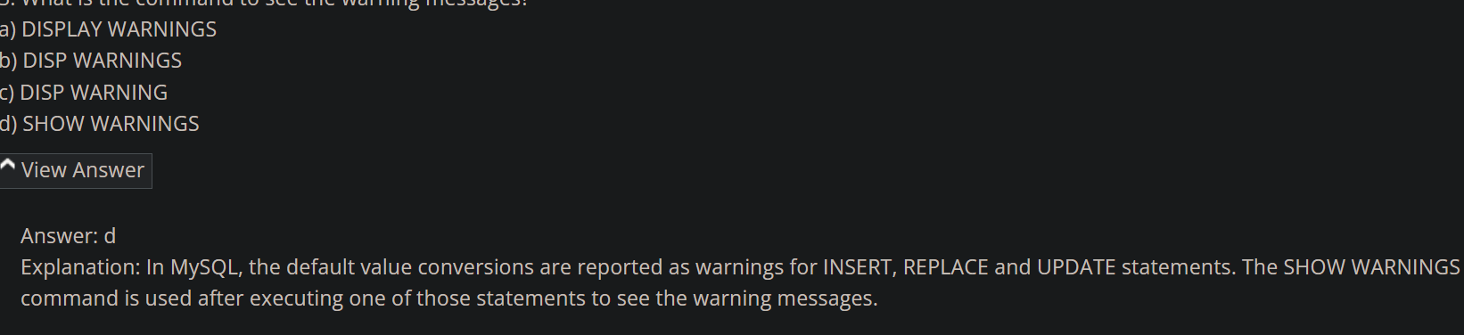

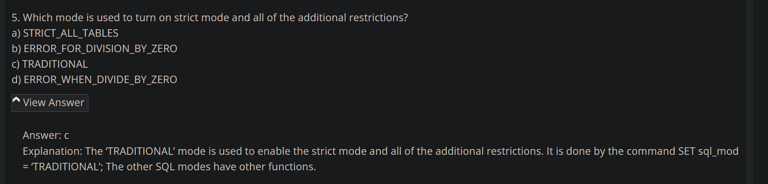

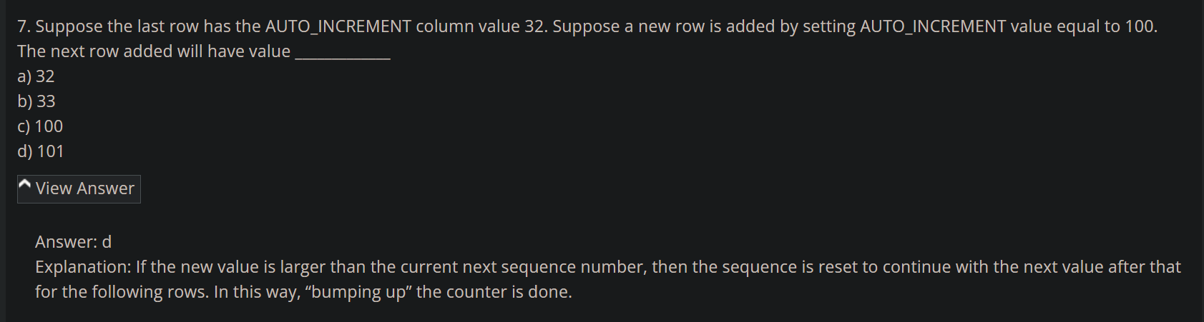

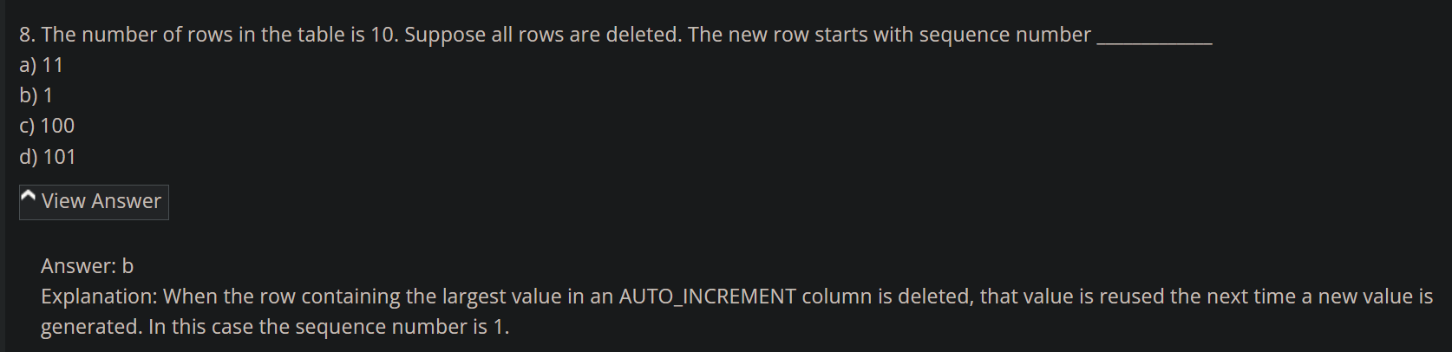

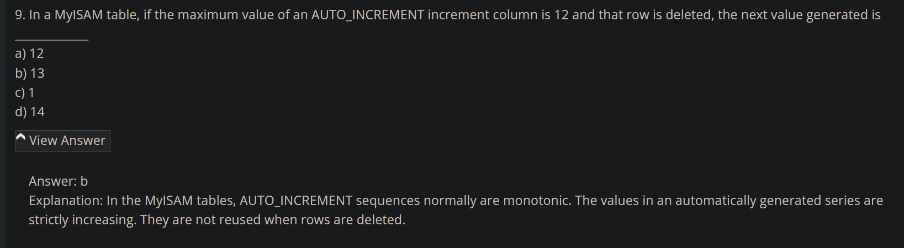

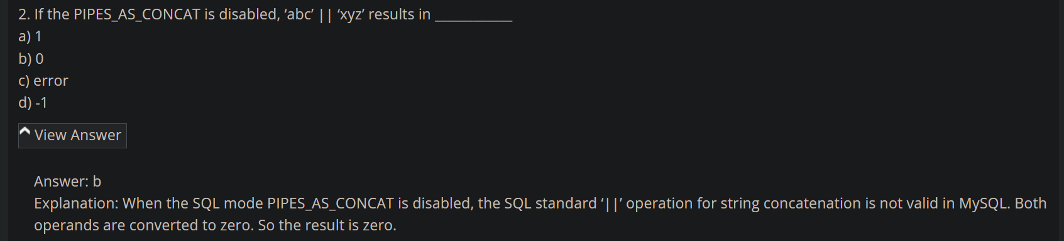

*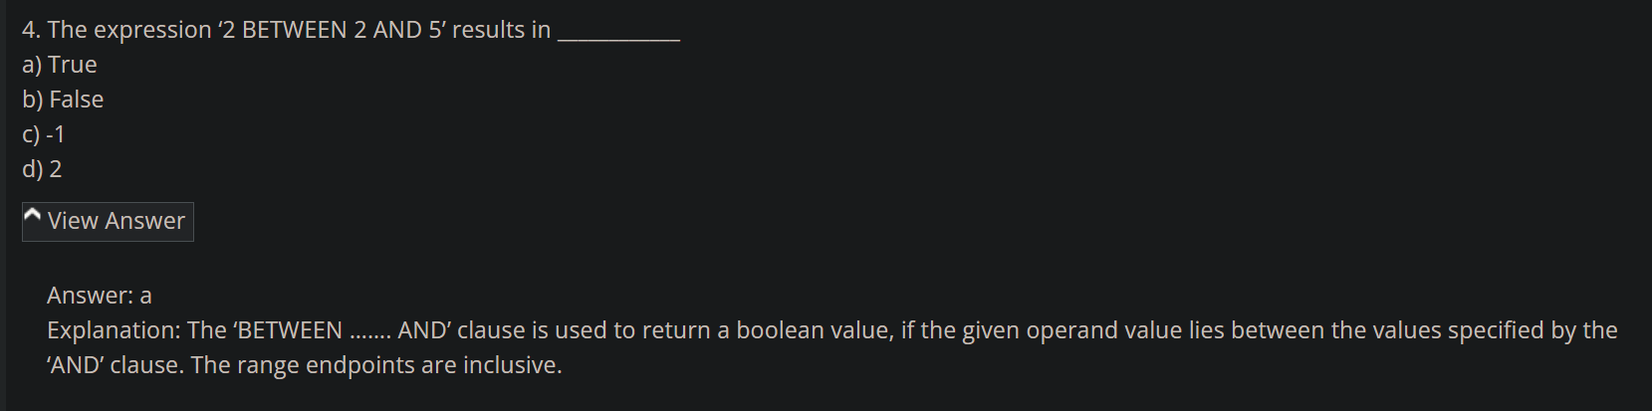

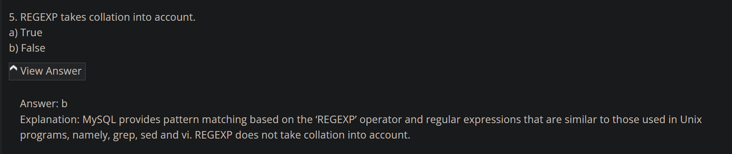

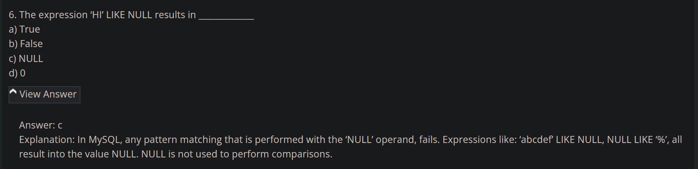

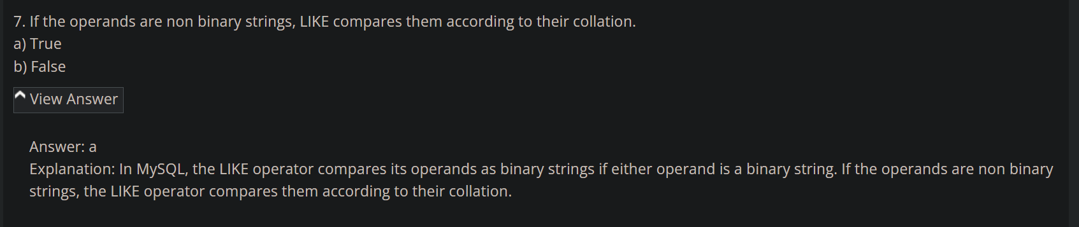

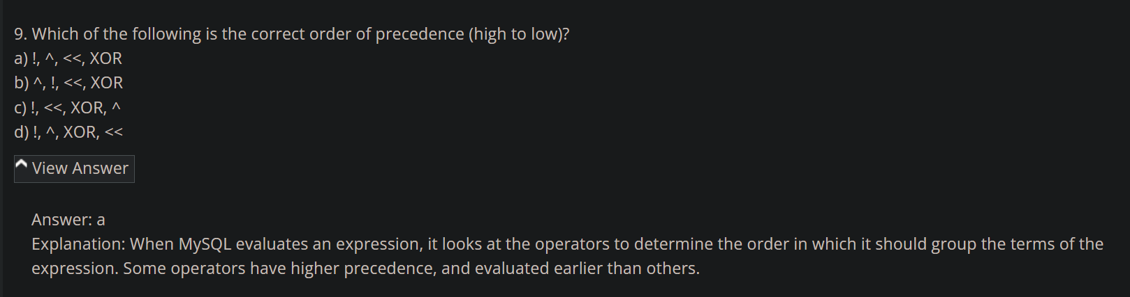

<https://www.sanfoundry.com/mysql-questions-answers-case-sensitivity-sql-statements/>

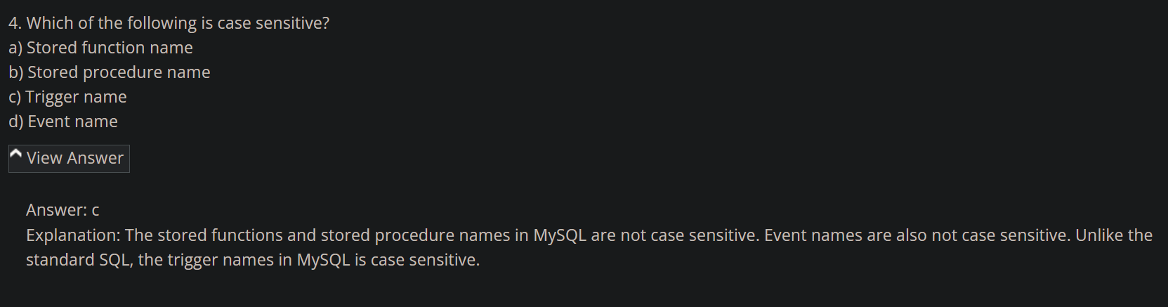

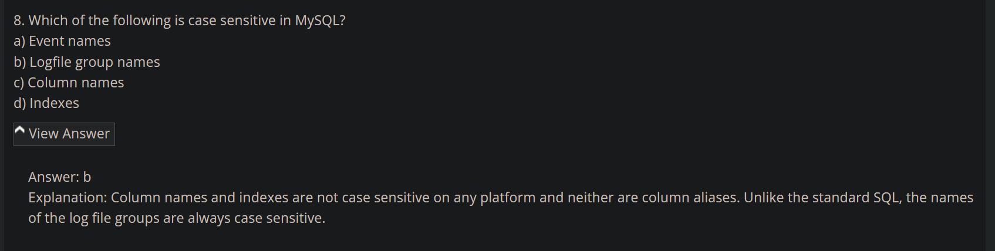

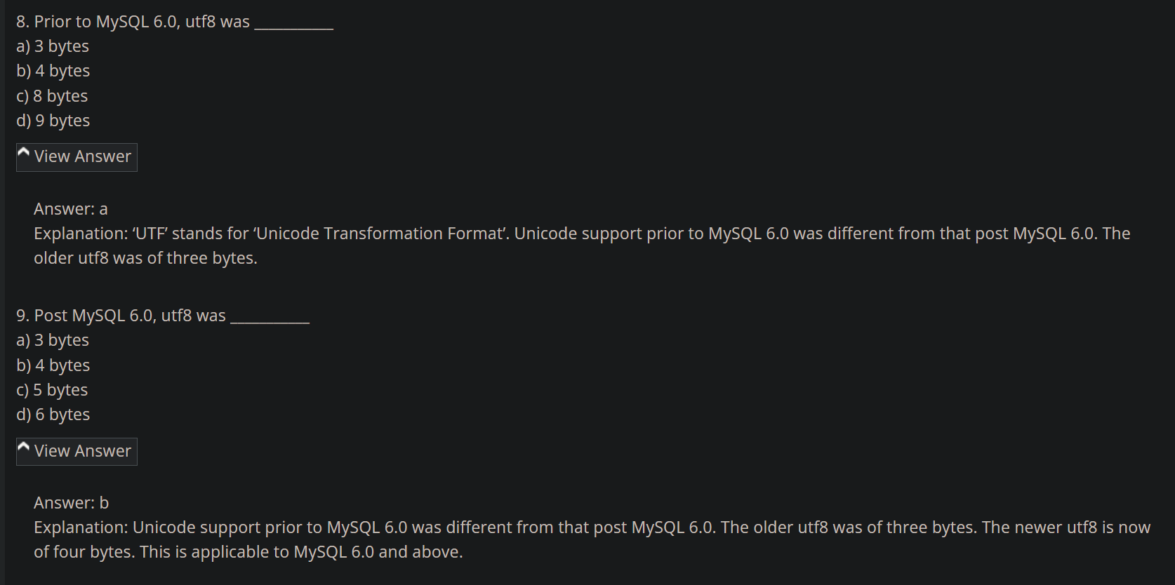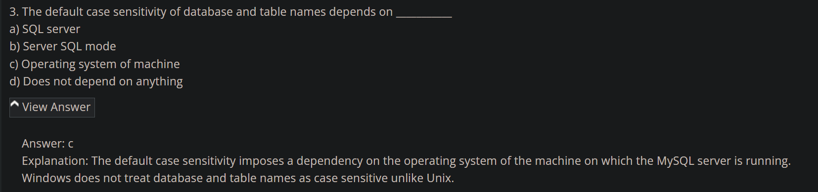

<https://www.sanfoundry.com/mysql-questions-answers-selecting-creating-dropping-altering-databases/>

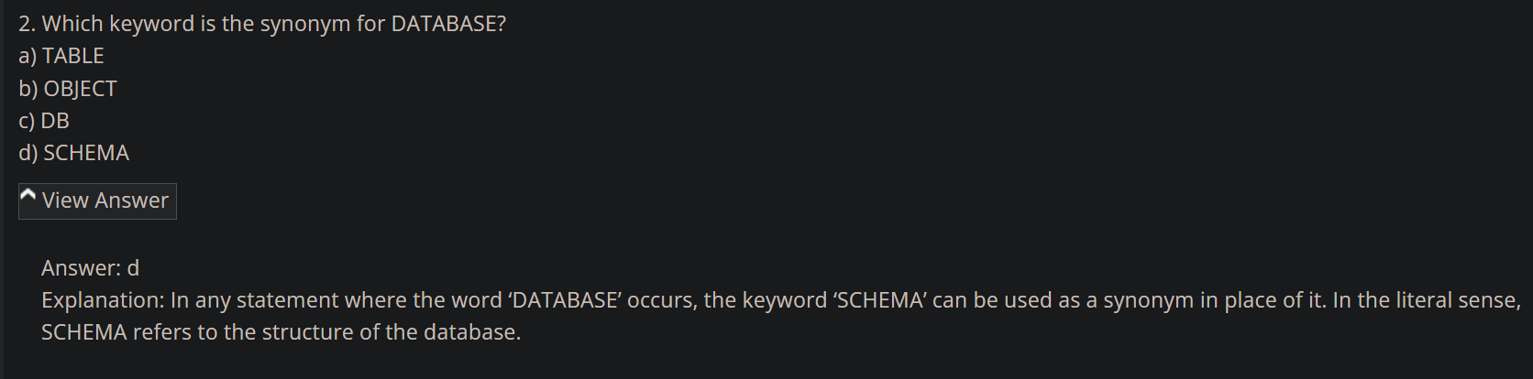

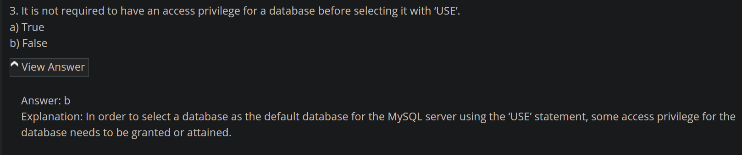

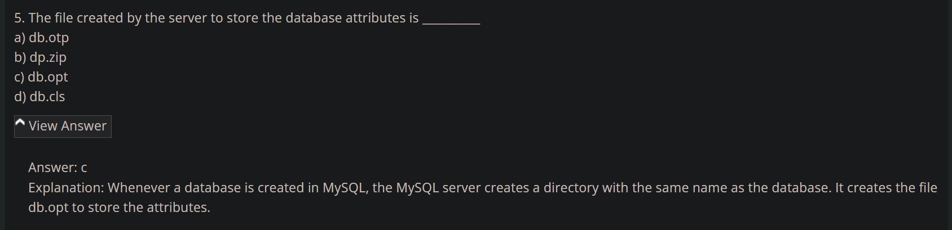

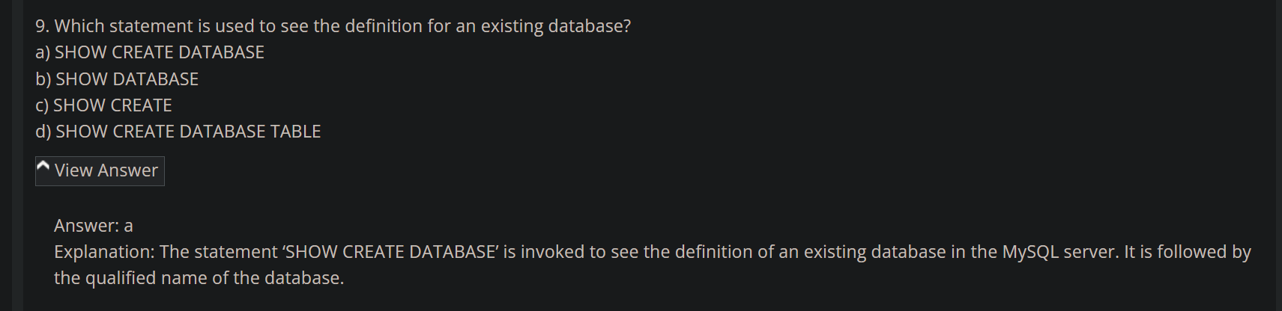

<https://www.sanfoundry.com/mysql-questions-answers-creating-dropping-indexing-altering-tables/>

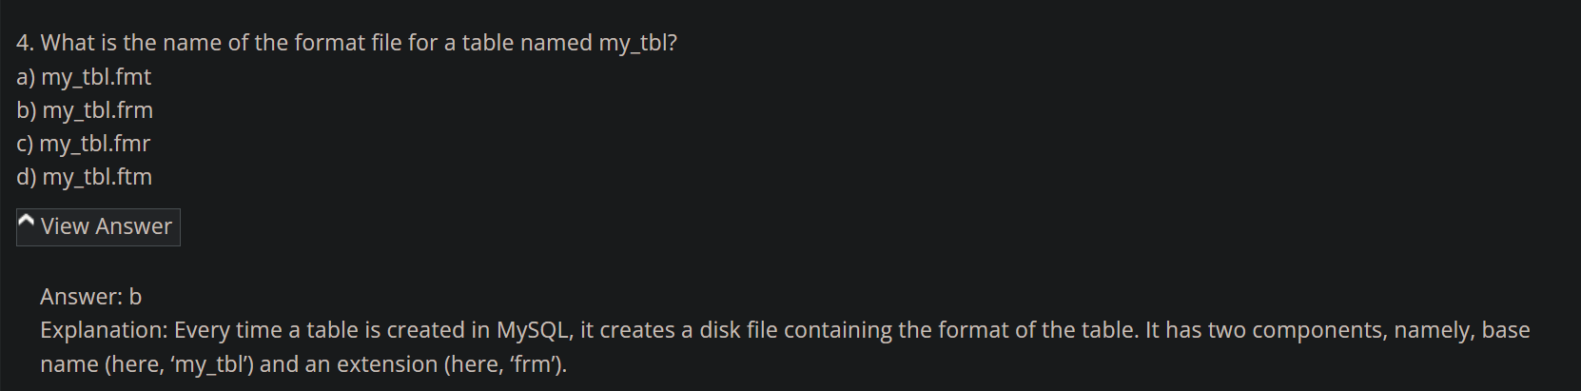

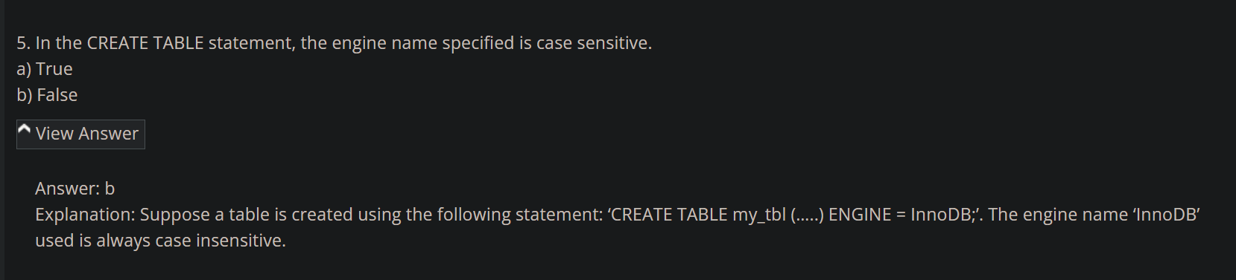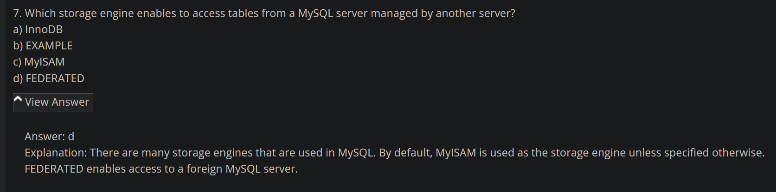

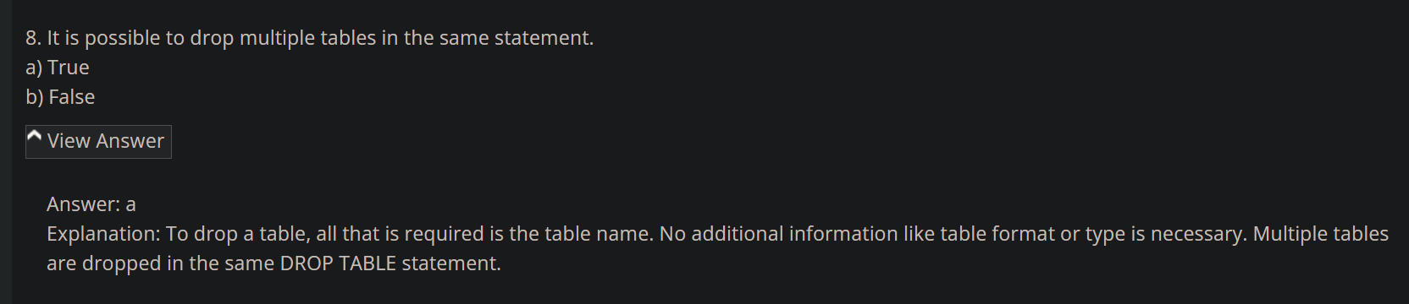

<https://www.sanfoundry.com/mysql-questions-answers-obtaining-database-metadata/>

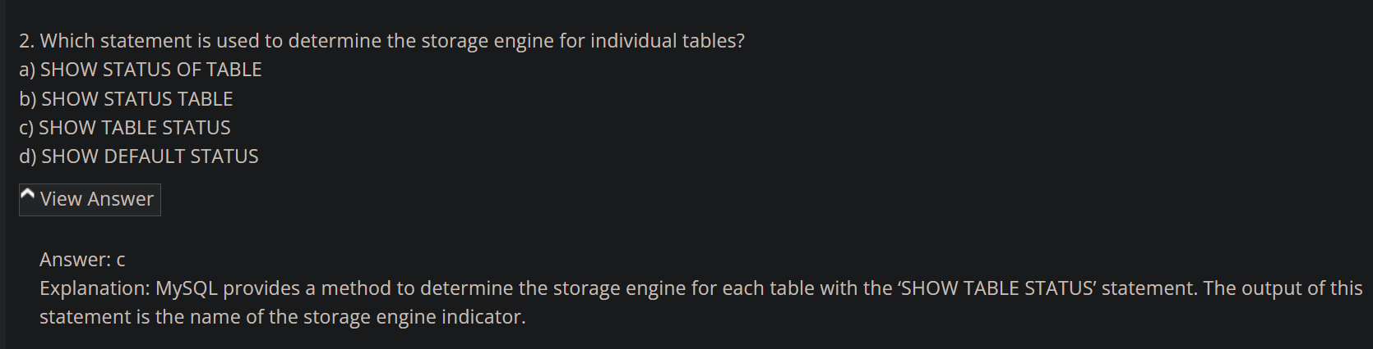

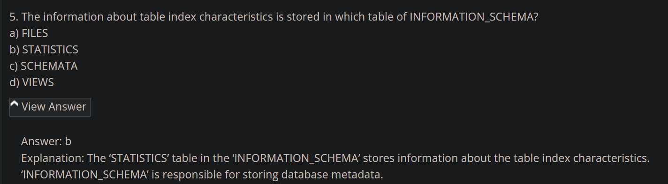

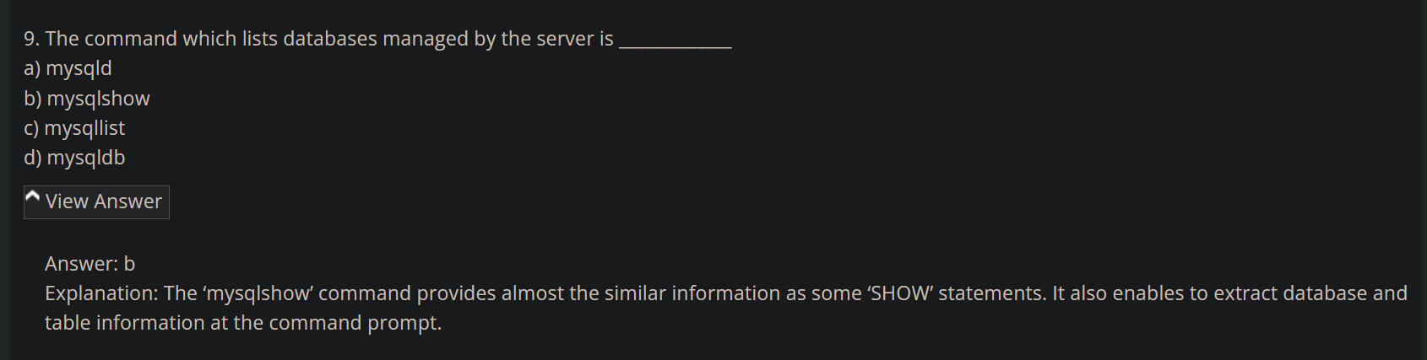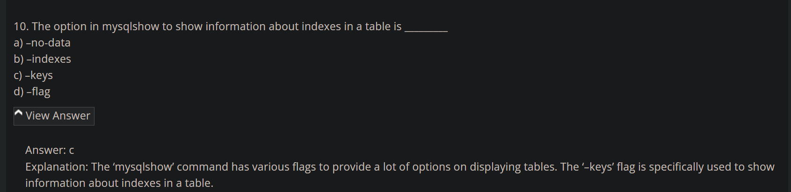

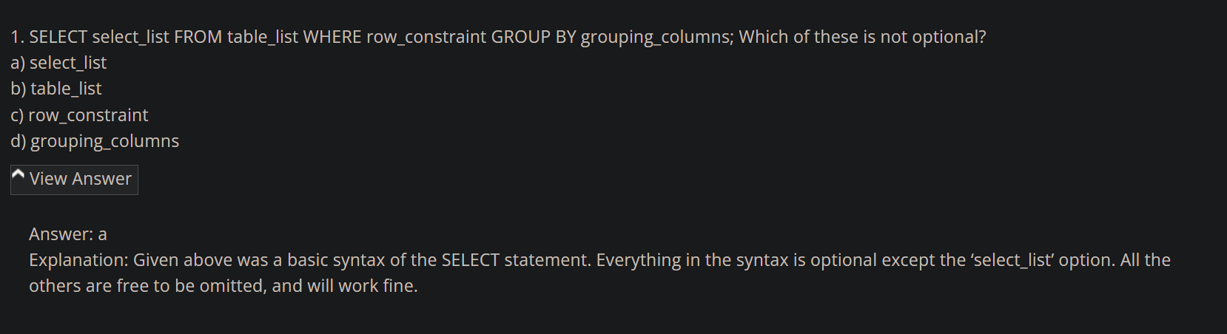

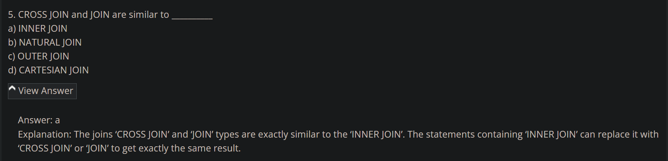

Which of the following statement cannot support triggers?

options

1. Insert statement

2. Select statement

3. Update statement

4. Delete statement

ChatGPT

Triggers in the context of databases are typically associated with Data Manipulation Language (DML) statements, which include INSERT, UPDATE, and DELETE. Among the provided options:

Insert statement: This statement is commonly associated with triggers. Triggers can be configured to activate before or after an INSERT operation.

Select statement: SELECT statements are used for querying data, but they don't directly modify the data in the database. Triggers are not typically associated with SELECT statements.

Update statement: Like the INSERT statement, UPDATE statements can also be associated with triggers. Triggers can be configured to activate before or after an UPDATE operation.

Delete statement: DELETE statements are commonly associated with triggers. Triggers can be configured to activate before or after a DELETE operation.

Therefore, the statement that cannot directly support triggers in the context of traditional database triggers is:

Option 2: **Select** statement

DBMS helps to achieve ______

options

1. Data independence

2. Centralized control of data

3. Both of above

4. None of above

ChatGPT

The correct answer is:

Option 3: Both of above

